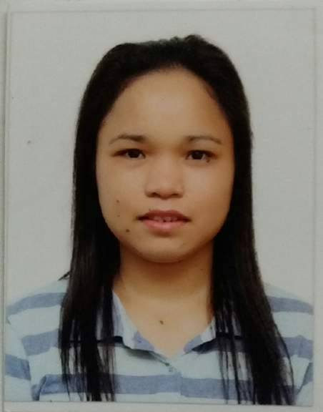
MARICOR

MARICOR.365397@2freemail.com

Career Objective:
To achieve my goals in life.

Summary of Skills:
- Proficient both oral and written communication with computer skills
- Ability to work and communicate with people of different level
- Responsible, committed to professional work
- Independent work with minimal supervision and contribute to team
- Willing to be trained, reliable, and can work in a dynamic environment

Educational Background:
2016-present : Master of Arts in Education major in Educational
Administration
Capitol University
Cagayan de Oro City, Philippines

2008 : Bachelor of Science in Secondary Education major in
General Science
Tagoloan Community College
Tagoloan, Misamis Oriental, Philippines

2001 : Del Monte National High School
Del Monte, Talacogon, Agusan del Sur, Philippines

1997 : Talacogon Central School
Talacogon, Agusan del Sur, Philippines

Trainings and Seminar attended:
November 2009 : Household Services NCII
TESDA-Pangulong Gloria Scholarships
Cagayan de Oro (Bugo) School of Arts and Trades
(27 days)

August 2009 : English Language and Culture
TESDA-Pangulong Gloria Scholarships
Cagayan de Oro (Bugo) School of Arts and Trades
(25 days)

August 2008 : “Teaching with Excellence: A Commitment to
One’s Purpose in the Classroom”
Pearlmont Hotel, Cagayan de Oro City, Philippines

Work Experience:
2015-2016 : Supervisor
KFC
Kuwait Food Company (Americana)
Abu Dhabi, United Arab Emirates
JOBS DESCRIPTIONS:
- Handling the staff with a positive manner managing the store customer oriented coaching and support to a team member
- Ensuring that checklists, requisitions and proper opening and closing functions are being completed each shift.
- Communicate with guests and employees using a positive and clear speaking voice, listen to and understand requests, respond with appropriate actions and provide accurate information.
- Ensuring that all steps of services as outlines in training materials are being followed on a daily basis.
- Ensure that all standards and restaurant cash handling procedures are met.
-Maintain cleanliness of all outlets on a daily basis.
- Ensure all daily and monthly reports are detailed and submitted in a timely matter.

2010-2015 : Service Crew/Cashier
KFC
Kuwait Food Company (Americana)
Abu Dhabi, United Arab Emirates
JOBS DESCRIPTIONS:
- Dealing with the customer in customer mania plus with the YES attitude
- Welcome customers as they come into the restaurant
- Help customers to settle down and also take their orders
- Process customers’ orders and generate their bills
- Provide answers to queries presented by clients regarding services and offers made available by the restaurant
- Clean all tables after clients have left and get such tables prepared for the next set of clients
- Serve and pack warm foods to clients in an effective manner and in strict accordance to the orders of such clients
- Assist kitchen staff and outdoor delivery staff whenever such assistance is required
- Maintain chart of all available deals and products periodically and refresh such chart on daily basis.

June 2009-August 2009 : Substitute Teacher
Sacred Heart Academy
Bugo, Cagayan de Oro City, Philippines
JOBS DESCRIPTIONS:
- Planning, preparing and delivering lessons to all students in the class
- Teaching according to the educational needs, abilities and achievement of the individual students and groups of students
- Adopting and working towards the implementation of the school development plan of the particular school they are giving service in
- Assigning work, correcting and marking work carried out by his/her students
- Assessing, recording and reporting on the development, progress, attainment and behavior of one’s students
- Providing or contributing to oral and written assessments, reports and references relating to individual students or groups of students

Achievements:
Best in Speed of Service
KFC CHAMPS (Nov. 11, 2013)

Employee of the Month
KFC (July 2013 and August 2013)

Employee of the Month
KFC (December 2012)

I HEREBY CERTIFY that the facts aforecited are true and correct to the best of my knowledge and belief.

