Ramachandra
Ramachandra.365426@2freemail.com
CURRICULUM VITAE
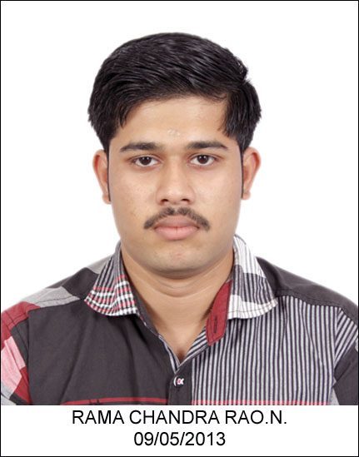

PERSONAL DETAILS
Date of Birth : 04/July/1989
Place of birth : Mavelikara
Nationality : Indian
Religion : Hindu, Gouda Saraswatha Brahmin
Gender : Male
Marital status : Single

ACADEMIC QUALIFICATION
Sl.No | QUALIFICATION | Institution | Year | Percentage
1 | S.S.L.C | Bishop Hodges H S S Mavelikara. | 2005 | 69%
2 | P.U.C | Bishop Hodges H S S Mavelikara. | 2007 | 66%
3 | B.sc Nursing | Manjunatha College of Nursing, Bangalore | 2007-2011 | 65%

Other Qualification
- Registered Nurse License from Indian Nursing Council (ICN).
- Trained and certified first aider.
CLINICAL EXPOSURE DURING THE ACADEMIC STREAM
Sl.No | Hospital | Departments
1 | Sapthagiri medical college, Bangalore | Obstetrics& Gynaecological Nursing
2 | N.R.R Hospital ,Bangalore | Medical surgical Nursing
3 | KC General Hospital , Bangalore | Paediatric Nursing
4 | Yelahanka General Hospital, Bangalore | Ortho& Medical surgical Nursing
5 | MIND Psychiatric Hospital, Bangalore | Psychiatric Nursing

Languages Known:
Read and write : English, Hindi, and Malayalam
Spoken : English, Malayalam and Hindi.
Strength:
- Confident& self-motivated
- Can work under pressure
- Sincere and committed to do work undertaken

Extracurricular Activities:
- Active in pulse polio Immunization program.
- Active in indoor and outdoor sports
- Active in school Health programme, Anganwadi programme
- Well versed in MS Office.
WORK EXPERIENCE
- Worked as a Staff Nurse in Casualty and Ambulance service at SAL Hospital, Ahmadabad, India from 26-10-2011 to 30-06-2014 and have 02 years and 08 months experience.
- Working as a First Aider (Male Nurse) in Al Raha Beach Development Project (A076) at Ghantoot Transport and General Contracting, Abu Dhabi, UAE from 13-07-2014 and still continue and have 02 years and 04 months experience
HOSPITAL INFORMATION
SAL Hospitals is 250 beds Multispecialty Hospital having all facilities. It is specialized mainly for cardiology and cardiac surgery. The hospital has a well-established advanced 05 bedded Casualty. The is well equipped with ventilator, cardiac monitors, defibrillators and infusion pumps. The cardiac monitors are equipped with ECG, NIBP, temp probe, SpO2, and CVP monitoring.

I hereby assure that the above-furnished details are true to the best of my knowledge.

