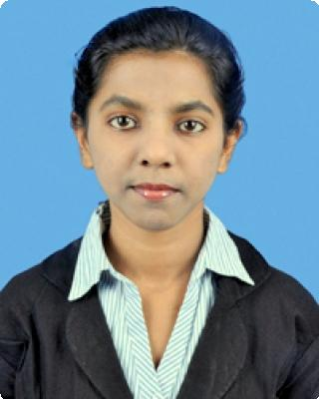JULI
JULI.365440@2freemail.com

Objective
Seeking a full time position in the IT and Software Engineering field to create new, manage, and enhance existing Business applications, Windows applications, Web applications, Mobile applications, and Cloud applications of IT Business systems.

Work experience
INFOSYS LIMITED MAY 2014 — Present

SENIOR SYSTEMS ENGINEER

Collaborated with users and other business teams to collect and gather system requirements for new applications. Translated user requirements into technical architectures, system designs and programming specifications. Designed, developed and maintained User interface, Web applications and Web services using Java framework on Eclipse IDE with back-end PostgreSQL.
Designed and developed cross-browser compatible front-end Java Servlet pages, JQuery and JavaScript components and web pages .
Created, maintained, and implemented SQL script, Ajax, JQuery script .
Integrated Java front-end technologies with back-end systems, Databases, MVC patterns. Revamped plan for existing User Interface Design from Spring framework to Angular 2 framework .
Managed and Implemented new methods and knowledge transfer to approach the detailed revamp plan . Created and maintained source code documentation, wireframes, screen-flow, code diagrams and charts.
Managed team inclination and dependency. Conducted mock up presentation and knowledge transfer to other team members.
Provided ongoing software support and troubleshooting, resolved bugs and queries related to User Interface, and issued resolution on application system defects.

Job Responsibilities
Conceptualized, planned and executed User Interface designs for a wide range of Infosys Infrastructure Management Solution Suite web project.
Created wireframes, flow diagrams and charts. Developed the Code as per system requirements.
Designed and developed new User Interface designs for delivery of the IIMSS product ensuring client satisfaction. Implemented Front-End Java pages and integrated JavaScript with Controllers in the back-end.
Provided ongoing software support , resolving bugs and User Interface queries. Conducted mock up presentation and knowledge transfer to other Team members. Created and maintained source code documentation, test plans and laid out designs.

Achievements
1

Gold Medalist in NRIKD Certified ALL INDIA COMPUTER KNOWLEDGE COMPETITION.
Nominated for Best Team Player in Infosys Cloud Ecosystem Hub.

Technical Skills
HTML/HTML5
CSS/CSS3
JQUERY
JAVASCRIPT
JAVA
AJAX
WEB DESIGNING
DATABASE: PostgreSQL
OPERATING SYSTEM: Windows
TECHNOLOGY: Client-Server Architecture, HTML, SQL.
DEVELOPMENT TOOL: Eclipse IDE, Apache Tomcat Server

Personal Skills
Fluent English and Excellent communication.
Team Leadership skills.
Strong analytical and problem solving skills
Goal oriented and results achiever.
Attention to Detail.

Education
Bachelors in Information Technology JAN 2010 — MAY 2014

Veer Surendra Sai University of Technology

CGPA- 8.00

References
References available upon request.

Languages Known
English - Fluent

Hindi - Fluent

2

