CURRICULAM VITAE

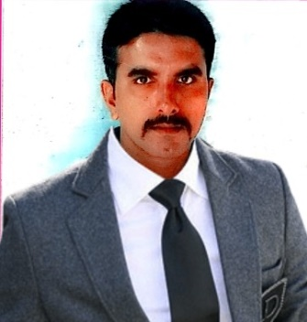
KAMALDEEN
KAMALDEEN.365441@2freemail.com

E-Mail:kamalgain@gmail.com

OBJECTIVES:

To bring my skill sets and experience into an organization and become a valuable member of the technology staff. To utilize my current skills to be benefit my employer while continually learning new technologies and methods to improve my employers use of technology and to enhance productivity, security and overall efficiency.

HIGHLIGHTS:

- 7 Years of Experience in production & Service Maintenance field
EDUCATIONAL QUALIFICATION:
- Diploma in Mechanical Engineering in Mohamed Sathak polytechnic college (Oct2007) - 63%
- Higher Secondary Certificate in Z.K.M. Hr.Sec.school  76% (March 2005)
- Secondary School Leaving Certificate in Z.K.M. Hr.sec school 77% (March 2003)

EMPLOYMENT HISTORY

1. ETA ASCON GROUP OF COMPANIES .DUBAI

Designation Diploma Engineer Trainee ( QC Site Supervisor)
Period Nov 2007 to Nov 2008.
Place & Site Dubai (World Tollest Tower)
Salary Rs.25,000 Pm

2. AMSARAJ TVS. SIVAGANGAI
Designation Service Advisor
Place Sivagangai
Salary Rs.10000
Period. Nov 2008 to APR 2013
Job Role & Responsible:
- To Handle Mechanics
- TO handle job card
- To Handle allotment of job card
- Job card entry
- To handle breake down mintenance
- To Maintain Register
- To maintain customer satisfaction
- REPORT to Service Manger
3. ST.ANTONY TVS.MARTHANDA
Designation Service Manager (Dealer Management in Tvs Motor Co ltd)
Period May 2013 to Dec 2016
Place Marthandam
Salary Rs.12000
Role & Responsible:

To Handle Mecanics ,Supervisor & Foremen
To Handle Moped & Motor cycle Service
Job card allotment
To Handle Service Auditing
To Handle Preventive Maintenance & Brake down Maintenance
To Handle Monthly Presentation
To Handle Customer Complaints
To Improve Quality
To Maintain All Register
To Maintain Customer Satisfaction at all our Business Associates
Reports to Territory Manager
TECHNICAL SKILLS:

- DCA
- AUTOCAD
- Inplant training in TNSTC(Bodinayakanur Tepo)
- Ms-Office

HOBBIES

Playing Chess , Reading Magazines And Automobiles Books, Hearing Music

Extra Curricular Activities
National Service Scheme Camp (Nss), Rotract Club of Ramnad, Director (Ramnad Dist).

I (KAMALDEEN) hereby declare that the above written particulars are true to the best of my knowledge and belief.

