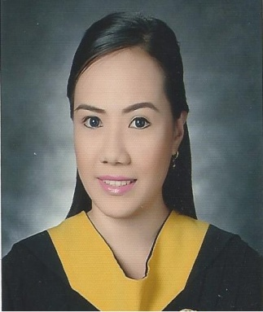

Sevillo
Sevillo.365486@2freemail.com

OBJECTIVES

To obtain an Office/Clerical position in which my customer service, personal, clerical and general office skills that will contribute to greater office efficiency and productivity

Special Skills

- Knowledgeable in using MS Word / MS Excel / MS Power Point
- Basic knowledge in Computer Troubleshooting
- Basic knowledge in using Adobe Photoshop

Work Experience

2015 April - 2017 April HRAD Staff/Receptionist
KC, Incorporated

- Assisting applicants and other visitors
- Responsible for monitoring of office staff attendance
- Responsible for the recruitment of office staff applicants
- Answering phone calls and other concerns
- Encoding, filing and monitoring office reports

July 2012 – March 2015 Telemarketer/General Clerk
Prudential Guarantee & Assurance, Inc.

- Responsible for convincing clients to renew their insurance
- Responsible for releasing and monitoring clients documents
- Entertaining phone inquiries
- Encoding production reports
- Filling documents

February 2008 – June 2010 Student Assistance in Registrar Office
STI College Caloocan

- Responsible for assisting students concern and request documents
- Responsible for releasing students assessment
- Responsible for posting job vacancies on school E2E website
- Entertaining phone calls
Educational Attainment

- Tertiary

June 2008 – March 2012 Bachelor of Science Information and Technology

STI College Caloocan

#375 GM Sandoval Bldg., 10th Ave., Brgy. 62 Caloocan City Philippines

Personal Information

Date of Birth : September 27, 1991
Civil Status : Single
Religion : Roman Catholic

I hereby certify that the above information is true and correct to the best of my knowledge and belief.

