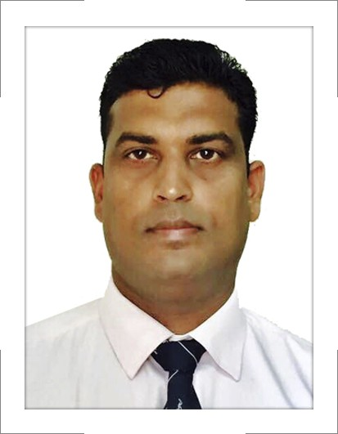Arun
Arun.365493@2freemail.com

SYNOPSIS
- A Competent Marketing Professional with 15+ year’s experience (5 years in Automobiles, 10 years in sales of Luxury boutique & Gems Stone).
- Seeking a challenging career in marketing to utilize my organizational and marketing skills, in order to increase productivity of the organization.

PROFESSIONAL AND ACADEMIC QUALIFICATIONS

Bachelor of Arts ■ Mumbai University, Mumbai, 2000.
One year Diploma in computer Hardware engineering from Jet king Institute, 2001.

PROFESSIONAL EXPERIENCE

The Spa Group (Since May'06)

The Spa Group is a consortium of Europe’s leading luxury tableware, home lifestyle brands and Gemstone
Division. We are also one of the largest luxury retail companies in India with Pan India presence of luxury
Boutiques.

M/s S.P.A Agencies India Pvt. Ltd. - Gems Stone Division
(Since May 2011).

REGIONAL SALES MANAGER- MAHRASTRA AND GUJRAT TERRITORY

- Responsible for the Region’s forecasting and sales tracking. Also, evaluating market trends and gathering competitive information for regional sales growth and profitability.
- Regular client visits to understand customer requirement and build strong business relationship.
- Represent brand strategy and positioning for each Brand of Cubic Zircons (American Diamond). Brands called
SPRANKEL, STANDARD & SUNSTAR. In term of values the Target per month is 1.5 million across all three brands.
- Identifying new areas for the potential business accordingly to appointed franchises & business
partners. The targets of Rs. 1 to 1.5 million have been met approximately every month.
- Marketing activities to strengthen sales and brand promotion by providing promotional tools like
twisser, trays and scoops time to time, and by making posters with Dealers Name.
- Order procurement and payment collections approximately value of 1 Million.
- Maintaining MIS for Order Booking and Dealer Processment and ledger etc in office 2007 Excel and Word.

M/s S.P.A Agencies India Pvt. Ltd. - Sole Distributors of LLadro & Nao
(March 2006 – April 2011).
STORE MANAGER
- Responsible to manage the showroom.
- Stock / Inventory Checks.
- Handling Shop n Shop sales and ensuring smooth transition of stock between POS and Boutique’s.
- Providing after sales services to Existing & new clients, & keeping them updated about new introduction, promotion & scheme.
- Handling the boutique staff and ensuring footfall conversion.

M/s Ichibaan Automobiles Pvt. Ltd. (Authorized Dealer for HONDA SIEL CO. LTD.)
(Feb 2005 - March 2006).
Sr. Sales Executive (Four Wheeler)
- Responsible for achieving sales target of total 15 vehicles in a month like 12 Honda city ,2 Accords
and 1 Honda CRV through Corporate / Major account.
- Advice which vehicles would Suit the customer best. Arrange Test- Drives .Work out Finance, including cash and car loan.
- Highlights extra products such as accessories or after Sales Service.
- Responsible for the sales process from initial point of contact, proposal to execution.
- To keep proper co-ordination between sales departments, customer care, operation department & utilize relationship to ensure that sales implementation schedules should fulfill.
- Reporting directly to sales manager about the day to day activity through daily sales report.

M/s SHREENATH HYUNDAI Pvt. Ltd.
(MAY 2004 to Feb 2005)
Sales Executive (Four Wheelers)
- Attending walk-in customer in showroom.
- Maximizing sales of new vehicles and achieving the assuring total customer’s satisfaction. Sales value 7 to 8 vehicles in a month.
- Advice which vehicles would Suit the customer best. Arrange Test- Drives . Work out Finance, including cash and car loan.
- Highlights extra products such as accessories or after Sales Service.

M/s Fucon Technologies Pvt. Ltd.
(March 2002 to May 2004)
Marketing Executive
- To supervise the technician under centers, which are undertaken as well as sales achieving target
sales achieve approx in values up to 0.6 to 0.8 million.
- Representing Automobile Accessories product which is applied (Antirust coating & Teflon Coating) in
the automobile Four Wheeler showrooms as well As Workshop.
M/s Syms Infotech
(October 2001- Feb 2002)
Customer support Engineer.
- In this job I had to look after the Computer peripherals.
- Configure computer systems, replacing parts as required.
- Diagnose hardware and software faults and solve technical and application problems.

TRAINING & PROJECTS
- Successfully completed Sales and Marketing Program Conducted by Honda Siel Co. Ltd. in 2005-06.
- Attended International Jeweler Trade Fairs.(IIJS 2013,2014,2015)

ACHIVMENTS
- Received appreciation for work on several occasions.
- Consistently surpassing and achieving the set targets.

Personal Details:
- Date of Birth: 16th Sep 1979
Marital Status: Married
Nationality: Indian
Languages: English & Hindi.

