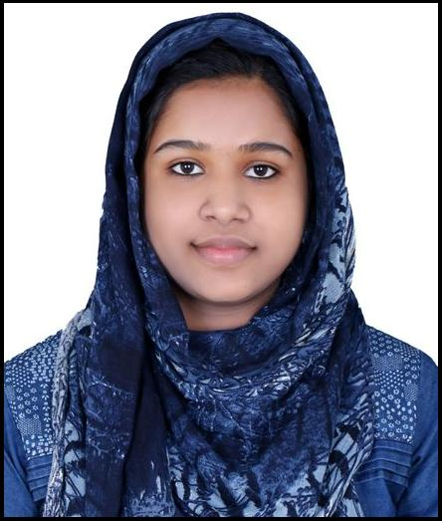​ RESUME​

SHAHINA

SHAHINA.365497@2freemail.com

​CAREER OBJECTIVE

To develop a career in professionally managed organization with opportunities for Innovation. I would like to work in an environment that facilitates Value Addition to the Organization with my knowledge and skill and where I can render selfless service to the same.

​EXPERIENCE

- Two year work experience as a​REGISTERED PHARMACIST​placed at ​PADMA MEDICALS

Thavanur. Kerala, from the period of 1st august 2013 up to 31st july 2015 (​KERALA STATE
PHARMACY COUNCIL, REGISTER NUMBER 47210).

- Holding​HAAD LICENSE (License NO: GP 17162​) at​MEDICURE PHARMACY ,
Mafraq Workers city 1, Abu Dhabi.

​EDUCATIONAL QUALIFICATION

1.Graduation:- Secured Bachelor of Pharmacy( B-Pharm) from JAMIA SALAFIYA PHARMACY COLLEGE, Pulikkal, Calicut During the period of 2008 september to 2013 march (University of calicut)

2.Higher secondary Education: Valanchery Higher Secondary School( march 2007, DHSE Kerala)

3.Secondary School Leaving Certificate( SSLC): MMM High School, Moodal( march 2005, SCERT, Kerala)

​ACTIVITIES

1.Actively participated and presented paper in seminar:National conference on Innovation in Pharmaceutical Science

2.State conference on PHARMACOLOGY.

SOFTWARE SKILLS

MS Office, knowledge in internet

PERSONAL DETAILS

​

Sex : FEMALE

Date of Birth ​: ​27/06/1990

Nationality ​:​Indian.

Religion ​:​Islam

Marital Status ​:​Married.

Visa Status : Husband Visa

Language known ​:​English, Hindi, Malayalam

​DECLARATION

I, the undersigned, hereby declare that the above stated documents are true to the best of Knowledge and Faith.

