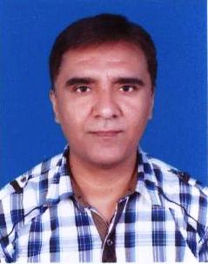

AZMAT

AZMAT.365498@2freemail.com

Personal Profile

MOH UAE License
DOB: 28-01-1972
Nationality Pakistani
Gender: Male.
Marital Status: Married
Religion: Islam.

Objective

To use my skills and seek for learning and best usage of my expertise in a challenging environment

Education

S.no. | Title | Year of passing | Board/university
1 | MBBS | 2000 | Voronezh Medical Academy
2 | B. Sc | 1993 | University of the Punjab
3 | F. Sc | 1991 | BISE Sargodha
4 | Matric | 1988 | BISE Sargodha
5 | Ielts | 2009 | Australian Bound
6 | Pain Management Course | 2008 | AACME American USA
Work and Learning Experience
p
Makkah Medical Centre Fujairah August2016 till to date Position; General Practitioner Rehmat Ul Aleen Hospital Sargodha Pakistan 1st March 2015 to july2016
Position; General Practitioner
MOH Saudi Araiba Dec 23,2012 to Feb 2015.
Position; Resident Medical officer.
Remat Ul Aleen Hospital Sargodha Pakistan Sep 15, 2001 to Dec,2012
- Position Resident Medical officer
Mayo Hospital Lahore Pakistan. Sep 1,2000-to Sep 1, 2001
- Position House officer

Accomplishment
- I dealt with all emergency cases
- I also assisted Seniors during various procedures and operations carried out in emergency and Operation theatre
- I also presented
- I also presented admitted cases during Rounds
- I worked under the supervision of my seniors to deal with indoor and outdoor patients
Linguistics Skills

- Urdu
- English
- German
- Russian
- Arabic

- REFRENCE WILL BE PROVIDED ON REQUEST

