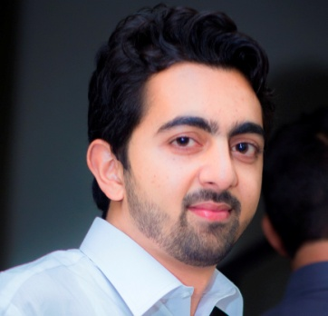

**MUHAMMAD**

[**MUHAMMAD.36554@2freemail.com**](mailto:MUHAMMAD.36554@2freemail.com)

* Be-Safe Virtual Clinic (Final Year Project) Android+Web+WCF
* Pharmacy Management System C# Desktop + SQL-Server
* Little Angel Baby Names Application Android + SQLite

Projects

* Web Services
* Json
* ASP .Net C#
* Desktop Application
* Java, Android Development
* Sql Server Management System
* C , C++

Area of Expertise & Skills

**Asst. IT Manager** Apr-14 to March-16

Malik Traders Pharmacy, Family Health Hospital

Sector I-10/4, Islamabad

**Asst. IT Manager**  July-12 to Feb-14

Medicamp Distributors,

Rawalpindi

**IT Operator** July-10 to June-12

Anees Medical Store, Combined Military Hospital

Rawalpindi Cantt

**DOB:**  20TH NOV, 1991

**NATIONALITY:**  PAKISTANI

**VISA STATUS:**  VISIT (exp. 20 June 2017)

Education

**BS (Hons.) INFORMATION TECHNOLOGY 2012-16**

PMAS-Arid Agriculture University

CGPA: 3.42 / 4.0

**Intermediate in Computer Science 2009-11**

Board of Intermediate and Secondary Education

Rawalpindi

**Matriculation**

Federal Board of Intermediate and Secondary Education

Islamabad

Experience

*Hi ! I am an IT Expert / software engineer by trade and by passion. An ambitious problem solver.*

*Right now I am looking for a suitable position with a company where outstanding performance is recognized and where I can work on a variety of high profile projects.*

A bout Me

PROFILE