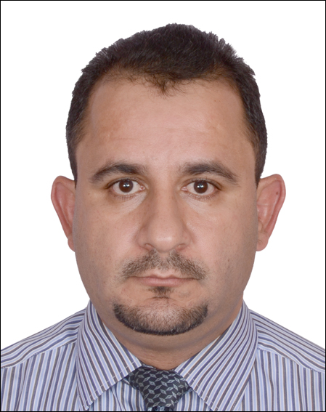
MOHANNED
MOHANNED.365537@2freemail.com

Education

Master Degree in Physics May-2007 to April- 2008
University of New South Wales
Sydney- Australia

High Diploma of Medical Radiation Physics October- 2000 to July- 2001
University of Jordan
Amman- Jordan
Bachelor Degree in Physics October-1995 to July-2000
Al-Albayt University
Mafraq – Jordan
Professional Qualifications

- Qualification in ESLM (English as a Second Language in the Mainstream)
- Certificate in Assessing Vocational Achievement
- Certificate in Training and Assessment
- Certificate in MOS (Microsoft Office Specialist)
- Certificate in IC3 (Internet Computer Core Certificate)
- Certificate in ICDL (Internet Computer Driving License)
- Certificate in INTEL
- Certificate in Freshman Teachers Course (Science Branch)
- Certificate in Science Activities Training Program
- Certificate in Inquiry and Activities
Employment History
Vocational Education Teacher (full time) [August] 2011 to present
Al Reef Institute of Logistics and Applied Technology – ADVETI
Subjects:
- Physics – for engineering students at Diploma and High Diploma levels
- Information Technology – for logistics, engineering, and Corporate training students
- Mathematics – for engineering students at foundational level, high diploma logistics students and engineering students at diploma level.
- Science – for engineering students at foundational level
Responsibilities:
- Adapt teaching methods and instructional materials to meet students' varying needs and interests, plan, prepare and deliver instructional activities.
- Plan and conduct activities for a balanced program of instruction, demonstration, and work time that provides students with opportunities to observe, question, and investigate.
- Use computers, audio-visual aids, and other equipment and materials to supplement presentations and create instructional resources for use in the classroom. For example, the Flash Professional Program (2D Animation Program) to produce and develop films on physic lessons for student use to gain a better understanding of the course or the Maya Program (3D Design and Animation Program) to produce films and clips for educational purposes.
- Establish clear objectives for all lessons, units, and projects, and communicate those objectives to students and utilize public library resources.
- Prepare objectives and outlines for courses of study, following curriculum guidelines or requirements of states and schools and establish and communicate clear objectives for all learning activities.
- Prepare reports on students and activities as required by administration and observe and evaluate student’s performance.
- Prepare, administer, and grade tests and assignments to evaluate students' progress and create projects designed to enhance lectures. For example, the Flash Professional Program (2D Animation Program) to prepare online exercises, quizzes and tests.

Other Duties:
- Organization Administrator for MOS & IC3 Center at Al Reef Institute.
Responsibilities:
- Conduct training on MOS & IC3 for students and staff.
- Curry IC3 & MOS online tests students and staff.

- Assessor at Yes to Work Program
Responsibilities:
- Plan assessment strategy for candidates at work placement.
- Carry out field visits for trainees
- Assess trainees and write final report
- Give feedback for trainees.
- Write final report to ACTVET

- Instructor at Skills for Life
Responsibilities:
- Plan for hands on projects for students to do.
- Supervise students
- Teach and train participants on animation programs

Teacher (full time) [September] 2008 to [August] 2011
The Logistic Academy – IAT

Subjects:
- Physics
- Information Technology
- Mathematics
Responsibilities:
- Preparing materials and classrooms for class activities.
- Establishing clear objectives for all lessons, units, and projects, and communicate those objectives to students.
- Maintaining grades or other forms of assessment and attendance and follow up with absences.
- Assessing student needs, abilities and determine whether students are making satisfactory progress in the course over time.
- Instructing students using a variety of teaching techniques.
- Maintaining knowledge of the current job markets in the Information Technology industry.
- Participating in team meetings regularly.

[Physics Teacher] (Full time) [September] 2005 to [January] 2006
Dubai National School
Responsibilities:
- Provide high quality of teaching and assessment of physics subject for high school level (grades 12, 11 and 10).
- Implement experiments in physics with students in the laboratories.
- Participate and take part in school activities.
[Physics Teacher] (Full time) [September] 2004 to [August] 2005
British International School of Tabuk
Responsibilities:
- Provide high quality of teaching physics (IGCS) for high school level.
- Teaching IT for year ten.
- Teaching Physics for years nine, eight, and seven.
- Implement experiments in physics and other science subjects with students in the laboratories.
- Form teacher for year eight.
- Participate and take part in school activities.

[Physics Teacher] (Full time) [October] 2000 to [August] 2004
Ministry of Education
Responsibilities:
- Provide high quality teaching physics for secondary students.
- Provide high quality teaching maths for grades ten to four.
- Provide high quality teaching Science for years six, seven, and eight.
- Being form teacher for years four and eight.
- Participate in school activities (field trips, sport activities).

Professional Computer Skills
I am professional in using the software:
- Flash Professional (2D Animation Program).
- Maya (3D Design and Animation Program)
- 3D-Max (3D Design and Animation Program)
- AutoCAD (2D & 3D design program)

Professional Skills
- Positive and professional attitude towards colleagues and students at all times.
- Ability to build supporting relationships with students
- Ability to monitor, assess and grade progress.
- Understanding and utilizing different learning strategies to reach all learner types.
- Time management and organisational skills so students receive all necessary information within a prescribed period.
- Adapt quickly to new situations
- Highly developed oral and written communication skills.
- Compliance with educational institutes’ regulations, policies and procedures.

Online

- YouTube channel (Skills for Educators)
Content: Contain videos that explain my courses and lessons on different subjects in the ICT.

- Website (Under construction)
Content: Information about me and my qualifications, Achievements, and future projects.
Publications

- How to use LMS(Learning Management System).
Content: How to use learning management system (Bright Space) on ankabut network.

- 2D Flash CS3
Content: A book for skills for life program students, where the book guide the students step by step using graphs showing how to use Flash software

Current projects

- Working on short videos that show and explain physics through projects. The videos will be on YouTube and my website.

- Using 3D & 2D animation software to make movies that show and explain physics principals.

Conferences
- Ankabut Conference (Paper Presented) Dusit Thani Hotel-Abu Dhabi Combine Software With LMS
[2016]

- IC13 Conference (Paper Presented)
Vice Roy Hotel-Abu Dhabi Using Macros in office suit for assessment [2013]

- IAT TEC Conference (Paper Presented)
Fatima College -Abu Dhabi Using animation programs in classroom [2012]

