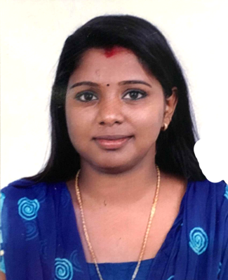
CURRICULUM VITAE

ATHIRA
ATHIRA.365546@2freemail.com

CAREER OBJECTIVE

To build career in a growing organization, where I can get the opportunities to prove my abilities by accepting challenges, fulfilling the organizational goal and climb the career ladder through continuous learning and commitment.

PERSONAL TREITS

- Hardworking
- Dependable
- Positive
- Self- Motivated
- Team-Oriented
- Organized
- Works Well Under Pressure
- Effective Communicators
- Flexible
- Confident

ACADEMIC QUALIFICATION

- ITI Architecture (NCVT) from Govt: P.T.C.M, Kerala, India (2011)
- AutoCAD from CAAD CENTRE, Kerala, India (2012)
- Tally from G-TEC computer Education, Kerala, India (2010)
- 12th Passed from Sreekrishna VHSS, Kerala, India (2010)
- 10th Passed from Sreekrishna VHSS, Kerala, India (2008)

WORK EXPERIENCE

- Draftsman at Jibu &Thomas Architect, Kerala, India since Oct 2014 – Dec 2016
- Draftsman at Guideline Designers and Engineers, Kerala India Since 2012-2014
COMPUTER SKILLS

- 3Ds Max 2014

- Auto Cad2D 2015

- Revit Architecture 2014

- Ms Office

- Tally 6.5

- V-Ray

ARCHITECTURAL DRAWINGS

- Apartments, Residents Buildings, Commercial Buildings, Commercial Cum Residence, Villa, Resort Plan and Elevation and Sections Details
- Group Housing Club and Guest House Building Details

- Interior Drawings

- Toilet and kitchen Details

- Stair Case, Compound Wall, Gate Post Details

- Landscape Detail Drawing

- Parking Layout and Different Type of Kerb Details

- Flooring, Ceiling Layout

- Municipal Drawing & Center Line

- Working Drawing and Sale Drawing

- Electrical Layout and Plumbing Layout

PERSONAL PROFILE

Nationality : Indian

Date of Birth : 7 -Jan -1993

Sex : Female Marital Status : Married Religion : Hindu
Languages Known : English, Hindi, Tamil, Malayalam

Declaration

I solemnly declare that all the above information is correct to the best of my knowledge and belief.

