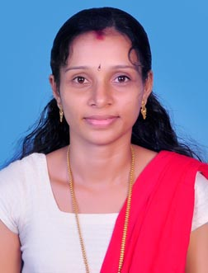CURRICULAM VITEA

SREEJITHA
SREEJITHA.365591@2freemail.com

PROFILE

In pursuit of a challenging career, I seek a job profile that would help me apply my knowledge and experience gained this far in productively contributing to the organization. Always enthusiastic to learn and committed to my work, I hope to be given an opportunity to work in an organization of your repute.
ACADAMIC QUALIFICATION

- DRAUGHTSMAN CIVIL (2009-Industrial Training Department , Kerala)
- PLUS TWO (2007-Board of Higher Secondary Examination)
- S.S.L.C (2005-Board of secondary Education, Kerala.)

TECHNICAL QUALIFICATION
- Completed Computer Courses (Autocad, 3Ds Max, MS office ,Excell and Browsing internet.)

EXPERIENCE

I Worked as draughtsman &site supervisor at Jayaraj Architects Kasaragod ,Kerala from 2010 to May 2016

Duties included

- Preparing plan ,elevation and section
- Preparing site plan
- Preparing drawing for municipal approval
- preparing Door and Window schedule &Detail
- preparing estimate

PERSONAL PROFILE
Date of birth : 15.06.1989
Sex : Female
Marital status : Married
Nationality : Indian
Mother tongue : Malayalam
Languages known : English ,Malayalam

DECLARATION

I hereby declare that the above furnished details are true to the best of my knowledge and belief.

