WANGA
WANGA.365600@2freemail.com

CAREER OBJECTIVE
An articulate, focused professional who has a proven history of gathering and analyzing information and then using the results of that analysis to make effective decisions and find innovative solutions to legal problems, ready for a new and exciting challenge with a driven and market leading legal firm where my experience, education, skills and abilities will add value to the company.

PROFESSIONAL OBJECTIVE

To pursue a position in a firm, combining legal expertise, strong practical experience, excellent communication and negotiation skills and customer service abilities.

CAREER SUMMARY

- Having 2+ years of experience in the law field.
- Represent clients in criminal and civil litigation and other legal proceedings, draw up legal documents, or manage or advise clients on legal transactions. May specialize in a single area or may practice broadly in many areas of law.

PROFESSION AL WORK EXPERIENCE
Kampala Associated Advocates (August 2014)
Kampala - Uganda
- Ready legal briefs and opinions and file appeals in state.
- Study the probable outcomes of cases.
- Review legal data to determine advisability of defending.
- Summarize and present cases to judges and juries.
- Gather evidence to formulate defense or to initiate legal actions, by such means as interviewing clients and witnesses to ascertain the facts of a case.
- confer with colleagues with specialties in appropriate areas of legal issue to establish and verify bases for legal proceedings
- oversee legal assistants and interns
- Assist in development of local and national programs, draft, interpret laws, legislation, and establish enforcement procedures.
- work in environmental law, representing public interest groups e.t.c
Lukwago & Company Advocates (Jan 2014 – November 2015) Kampala - Uganda
- Advised clients on various laws and jurisdictions concerning business transactions – Assisted clients in learning about their rights and obligations concerning business transactions.
- Represented clients in courts of law regarding various legal matters.
- Studied complex legal cases and summarized them for concerned authorities and jury members.
- Facilitated issues between clients by assisting in out-of-court settlements and compromises.
- Conducted detailed research to collect evidences and prepare statements.
- Acted as an advocate or legal advisor – Assisted clients in solving legal or criminal litigation by representing them in the court of jurisdiction.
- Assisted clients by studying their case and collecting evidence beneficial to their interest, thus inclining the judgment in their favor.

Education Background

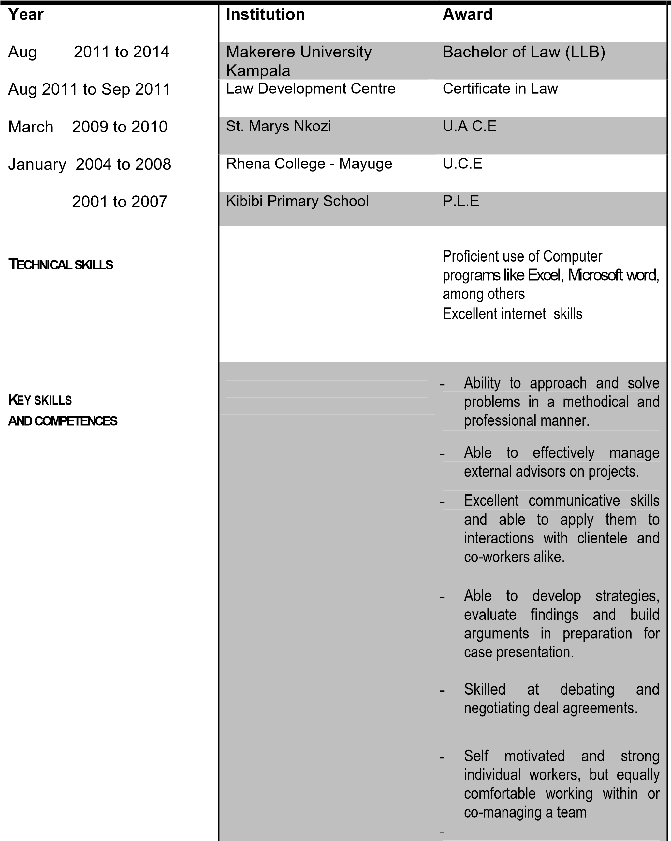

ATTRIBUTES AND COMPETENCIES:

I am an assertive person with high levels integrity, and am a persuasive team builder capable of relating and creating trust in all.
I like facing new challenges and I have the ability to motivate and achieve exceptional organizational/business performance besides that I am an experienced and creative TEAM PALYER with excellent Managerial skills which I have also acquired excellent Leadership and am capable of easily fusing and team-working with all kinds of personalities at different levels.

LANGUAGES
LANGUAGE SPOKEN
English - very fluent
Luganda - very fluent

HOBBIES AND INTERESTS
Business networking, travelling and learning, Gymnastics and exercising , Sports and games especially foot ball and volley ball, Community policing, Facing new challenges

