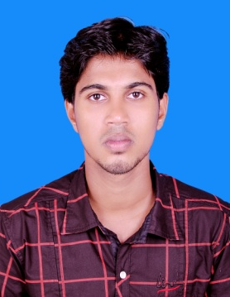
CURRICULAM VITAE
UNAIS
UNAIS.365610@2freemail.com

CAREER OBJECTIVES
Seeking the position of a medical coder in an organization that will give me an opportunity to become a successful professional having a strong understanding of the underlying principles and influencing forces within the industry.

SKILLS
- Can be a good team member especially in situations where tough & high stress goals have to be achieved.
- Can take initiative, work under pressure & balance multi task assignments.
- Thorough knowledge of office operations, organizational & administrational skills, which are highly effective & methodical portraying maturity & professionalism.
- Adaptive, practical and straight forward.

EDUCATION PROFILE
SL No | Qualifications | College/ School | Board/ University | Percentage
1 | CPC | AROWN Medical Coding Academy, Calicut | AAPC | 78%
2 | B. Sc NURSING | Acharya Institute of Technology, Bangalore | RGUHS Bangalore
3 | XII | Govt. Higher Secondary School Athavanad | Government Of Kerala | 63%
4 | SSLC | Cherural High School , Kurumbathur | Government Of Kerala | 70%

PERSONAL DETAILS
Date of Birth : 30/12/1989
Marital Status : Married
Languages known: English, Malayalam, Tamil, Kannada & Hindi

DECLARATION
I hereby declare that above statement are true to the best o my knowledge & belief.

