RESUME
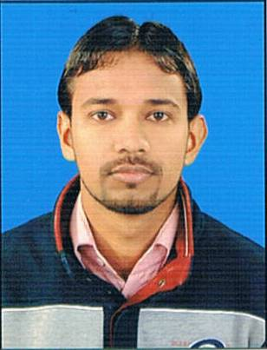
VINEET
VINEET.365623@2freemail.com
CAREER OBJECTIVE:
To work in an organization with the responsibility and dedication to the job and putting more efforts to achieve the vision and mission of the company as well as an individual and in association with the team.
PROFESSIONAL EXPERIENCE (5+ years):
- Skyline Institute of Engineering & Technology: (From July 2011 to June 2013)
As a Lecturer:
Worked as a Lecturer in Mechanical Deptt. & subject mentor of the following subjects:
- Refrigeration & Air-Conditioning (RAC)
- Heat & Mass Transfer (HMT)
- Thermodynamics
- SOFCON India Private Limited: (From June 2013 to Present)
As a Technical Head -Training (Building Automation + HVAC Design & Drafting):
- SOFCON is the only company which provides training in the field of Integrated Building Automation/Management System (IBAS/IBMS) in all over India. As a Technical Head, I executed In-plant training programs for various corporate/companies & provided training to 500+ engineers, engineering professionals & Students from abroad in regular training programs in training centers on the following topics:
- Building Automation System: Refrigeration Cycle, Psychrometry, Heat Load Calculation, HVAC, Inputs & Outputs, Sensors, P&ID Diagram, I/O Summary, and BMS Architecture
- Fire Detection & Alarm System: Fire Life Cycle, Detection technologies & Detector selection, Fire Panels, Input /Output Devices, NFPA 72 Guidelines, Fire Safety Strategies
- Fire Suppression System: Fire Retardants, Cleaning Agents, CO₂ System, FM 200 or NAF227, Inergen, Argonite and VESDA
- CCTV Surveillance System: IP-CCTV & Analogue CCTV , DVR & NVR systems, Video analytics
- Access Control System: Access control technologies, Access control Equipment, Biometrics, Physical barriers
Now a days, HVAC is the fastest growing field for all Mechanical Engineers. We can find the various application of HVAC in following fields:
- Metro Stations
- Airport Stations
- Shopping malls & Complexes
- Hotels
- Apartments………etc
We cover the following contents in “HVAC Design & Drafting” as follows:
- Basics of HVAC
- Heat Load Software (E-20)
- Duct Designing (Mc-Quay Software)
- Hydronic Systems
PROFESSIONAL QUALIFICATION:

QUALIFICATION | BOARD/UNIVERSITY | PASSING YEAR | PERCENTAGE
B.Tech (ME) | UPTU, Lucknow | 2011 | 72%
12th | U.P.Board, Allahabad | 2006 | 79%
10th | U.P.Board, Allahabad | 2003 | 62%

INDUSTRIAL TRAINING:
- Name of the Organization : Larsen & Toubro
- Training Area : Heat Ventilation Air Conditioning (HVAC) and Fire Fighting
System
- Training Description : Training gives practical knowledge related to HVAC and Fire
Fighting systems used in modern buildings
- Training Duration : 6 weeks
PROJECT UNDERTAKEN:
- Project name : Study of Heat Exchanger
- Description : Calculate the heat transfer rate of a pipe

PERSONAL DETAILS:

- Date of Birth : 16th September 1989
- Marital Status : Single
- Father’s Name : Dinesh Chandra Sharma
- Languages known : English, Hindi
- Hobbies : Watching cricket, Cooking

DECLARATION:
I solemnly declare that information given by me is true and correct the best of my knowledge and belief and nothing has been concealed.

Date………….. (Vineet)

