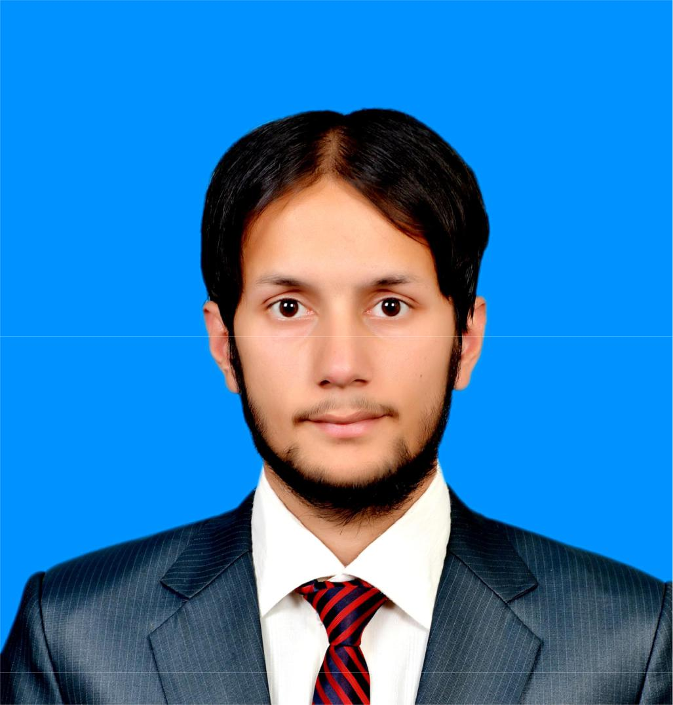

Ahsan

Ahsan.365652@2freemail.com

CareerObjective:

Looking forward for an organization that offers a challenging, stimulating learning environment to work in and provide scope for individual & organization development, which offers attractive prospects for long term development and career growth.

EducationalBackground:

Graduation (2014):

Comsats Institute Of Information & Technology

Total C.G.P.A = 4.00

Obtained C.G.P.A = 3.70

Intermediate (2008):

F.G. Degree College For Boys

Total Marks = 1100

Obtained Marks = 722

Matriculation (2006):

Farooqi Ideal Public School

Total Marks = 1050

Obtained Marks = 807

Strengths:

Hardworking & Friendly

Disciplined & Punctual

Honest.

TechnicalSkills:

Microsoft Office (Word, Excel, Power Point)

Fast Data Entry With Accuracy

Language C, C++

Java

Designing System Softwares

Auto-Cad

Proteus

Matlab

Packet Tracer (CISCO)

Keil

HFSS

SemesterProjects:

Project # 1: Voice or Sound Amplifier

Duration: One Month

Team Strength: Two Members

Project Description: Electronics Project Using Darlington Pair Of NPN-Transistor.

Project # 2: Hotel Reservation System

Duration: One Month

Team Strength: Two Members

Project Description: Introduction To Computer Programming Project Using C,

C++Languages.

Project # 3: Independent Component Analysis (ICA) Or Blind Source Analysis

Duration: Two Months

Team Strength: Two Members

Project Description: Digital Signal Processing Project Using MATLAB

Final Year Project:

Project Title: Design & Develop Solar Based Efficient Power System

For Domestic Applications

Duration: One Year

Team Strength: Four Members

Project Description: Our Project main concern is to develop & design an optimal efficient

power System for domestic applications. As our project work based on the COTS (Commercial Off The Shelf) means we pick the latest updated market components or different parts for building a daily life usable system that is efficient.

Internship:

Worked At HMC (Heavy Mechanical Complex)

Duration: One Month

Departments: Production & Planning Control

NDT Laboratory

Maintenance Department

Power House

Telephone Exchange

Winding Shop-2

ProfessionalExperience:

Worked in a WINCOM Company as an Assistant Manager Electrical (Duration: March 2014 to April 2015)

Worked in a Relacom Company as a Site Engineer Electrical (Duration: May 2015 to June 2016)

Achievements&Honours:

1st Semester: 3rd Position

2nd Semester: 4th Position

3rd Semester: 4th Position

4th Semester: 4th Position

5th Semester: 3rd Position

6th Semester: 3rd Position

7th Semester: 3rd Position

8th Semester: 2nd Position

During My University Life, Positions that I hold are listed below:

Electric Machines Final Lab (Incharge)

Project Leader In All My Semester Project Final Year Project Leader

Study Tower At Pakistan Ordinance Factory (Team Leader)

OutOfFieldWorkExperience:

- Working Online As a Forex Retail Trader At “Etoro (Europe) Ltd [CY]”.

- Working Online As a Sales and Marketing Of Goods And Services With Companies Listed

Below:

- Clickbank

- Google Adwords

- Empowr

- Working Online As a Bitcoin Miner.(I’m able to convert Electricity into Money Efficiently).

