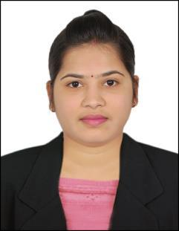
CURRICULUM VITAE

SUDHARANI
SUDHARANI.365671@2freemail.com

CAREER OBJECTIVE

Seeking a position in an organization to excel, to learn and deliver the best of my abilities and given tasks.

EDUCATIONAL QUALIFICATIONS

• Board of Intermediate

EDUCATIONAL PROFILE

COURSE |  | INSTITUTION | UNIVERSITY/BOARD |  | % MARKS
SSC |  | NIRMALA HRUDAYA | ANDHRA PRADESH |  | 82.60%
 |  | SCHOOL,NIZAMABAD
 |  | GOUTHAMI COLLEGE | ANDHRA PRADESH |  | 91.8%
INTER MEDIATE |  | NIZAMABAD

SOFTWARE SKILLS

- Ms office (word, excel, powerpoint, outlook)
- Internet

WORK EXPERIENCE

●Worked As A Receptionist/admin For Fakih Group of Companies U.A.E From 15-10-14 to 30-01-17.

● Worked As A Receptionist/admin For Jasper Industries Pvt Ltd H.Y.D 15-10-14 to 30-01-17.

DAY TO DAY RESPONSIBILITIES:

- Reads and routes incoming faxes, incoming & outgoing mail. Locates and attaches appropriate file to correspondence to be answered by the concern person.

- Answers and screens incoming calls.

- Prepares outgoing mail and correspondence, including e-mail and faxes.

- Orders and maintains supplies, and arranges for equipment maintenance.

- Entertains and assist the visitors

- Develops and maintains confidential or complex files.

- Prepares invoices and payments of claims, requisitions, purchase orders and other fiscal duties.

- Keeps calendar, sets up meetings, makes travel arrangements and appointments for the employees.

- Maintains office filing and information storage systems, performs information filing and retrieval services, and maintains databases, correspondence files, information files, mailing lists, and related information.

- Ensures that all copy of all documents passed sent/received between parties is held securely and will readily available.

ACTIVITES OF INTEREST

- Listening Music
- Travelling,

- Playing & Making Fun Around with Friends

STRENGHTS
- Confidence
- Team Work
- Hard work

DECLARATION

I hereby declare that all the information furnished by me in my resume is true to the best of my knowledge and belief.

(SUDHARANI

