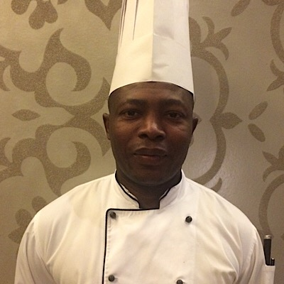
NAME : JEAN
JEAN.365686@2freemail.com
COMMIS 1
OBJECTIVES:
A highly motivated and capable professional commis 1 with a real passion for preparing popular, healthy and nutritious meals. Having a hand on approach to all areas of kitchen and possessing excellent organizational skills and administrative skills. A quick learner who can effortlessly fit into an existing established environment, and also encourage junior staff to achieve their best when preparing meals.
SUMARRY OF QUALIFICATIONS
- Over 7 years of experience as cook.
- Certified in international cooking, French, Greek, Lebanese…
- In depth knowledge of principal tools and equipment used in cooking.
- Ability to work with advance tools and equipment.
- Possess high level technical and troubleshooting abilities.
- Excellent communication skills in written and verbal English and French.
- Computer knowledge.
Professional experience
June 2014 SWBH ( SOUQ WAQIF BOUTIQUE HOTELS ) DOHA QATAR TILL DATE
Duties
- Preparing daily butchery for functions
- Live cooking in breakfast station
- Looking after Ala Cart
- Receiving of stores
- Making monthly inventories
- Maintaining standard according to municipality laws.
- Cold kitchen in charge during shift work
August 2006 to September 2013, RESTAURANT MEDITERRANEE DOUALA CAMEROON.
Duties
- Preparing Ala Cart
- Doing production for functions
- Butchery for Ala Cart
- Worked in Ala Cart for both hot and cold section
ACHIEVEMENTS
- employee of the month September 2008
- nominated as employee of the month November 2014

EDUCATIONAL BACKGROUNG

- 1992 : BEPC ( GCE Ordnary LEVEL Certificate )
- 1997 : Certificate of Professional Cook
HOBBIES
- Sport
- Reading
- Music
- Internet

