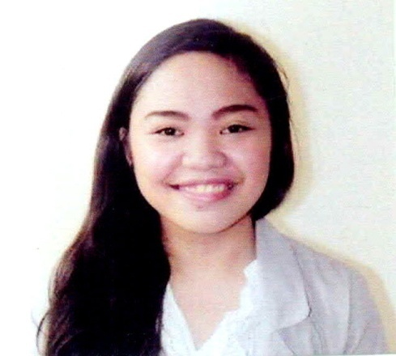
Anna
Anna.365692@2freemail.com

PERSONAL BACKGROUND
Age : 21
Gender : Female
Civil Status : Single
Place of Birth : Cebu City, Philippines
Date of Birth : October 18, 1995
Citizenship : Filipino

CAREER OBJECTIVE
To utilize my skills and capabilities
To maximize my potential and provide effective, efficient and flexible services in contribution to the company’s growth and profitability

EDUCATIONAL BACKGROUND

College
University San Jose –Recoletos
Magallanes St., 6000 Cebu City
Course: Bachelor of Science in Business Administration - General
Year Graduated: October 2015

Secondary
Advance Institute of Technology
Sangi, New Road, Pajo, Lapu – Lapu City
Year Graduated: March 2012
Achievement: 6th Honor

Elementary
Mactan Air Base Elemetary School
Mactan Ebuen Benito Air Base
6015 Lapu- Lapu City
Year Graduated: March 2008

WORK EXPERIENCE

OJT – PAG-IBIG Fund WT Corporate Tower
Mindanao Avenue, Cebu Business Park, Cebu City
Year: November 2014 – January 2015

ACCOUNTS PAYABLE / BILLING CLERK
UNIVERSAL ROBINA CORPORATION – CEBU PLANT
P.C.Sulco, Mandaue City, Cebu
Year: December 2015 – March 2017

SKILLS
Entrepreneurial Skills
- Communication
- Flexible
- Goal Oriented
Computer Skills
- Microsoft Word
- Microsoft Excel
- Microsoft Power Point
- Internet Savvy
Customer Service Skills
Interpersonal Skills

SEMINARS ATTENDED

August 1, 2015 – Positive Mindset in the Business Industry
University of San Jose - Recoletos

September 8, 2015 – Finding Business through Travelling
University of San Jose - Recoletos

October 3, 2015 – Job Hunting and Labor Education Seminar
University of San Jose - Recoletos

ACTIVITIES ATTENDED

June 4-October 2, 2015 Student Trainee – SAP Business One
University of San Jose – Recoletos

July 11, 2015 Organizer – Credit Assessment and Collection Strategy
University of San Jose – Recoletos

March 29, 2014 Volunteer Facilitator – Enrollment Assistance
University of San Jose – Recoletos

AFFILIATION

Peer Facilitator - Student Development Placement Center
University of San Jose – Recoletos
Year: 2013-Present

Member - Junior Business Executive and Entrepreneurship Society
University of San Jose – Recoletos
Year: 2012-Present

CHARACTER REFERENCE UPON REQUEST

