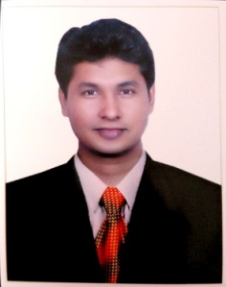
SUJAN
SUJAN.365702@2freemail.com

To work in a competitive environment & enhance my qualifications and work experience which will help me as well as my workplace to grow on both

Profile Summary

- Familiar with :
O PLC, SCADA, VFD, HMI, PAC Designing and Troubleshooting
O Various Industrial Instruments Calibration and controlling
- Ability to evaluate and interpret unique problems with a combination of training and logical thinking to find the right solutions
- Possess a flair for working hard and contributing towards achievement of organization goals

Professional Experience

- Working with SMEC Automation Pvt Ltd as a service engineer past 1 years 10 months
- Worked on M340 on Crude Tanker Vessels
- Worked on Commissioning of brewery Plant at Mangalore
- Worked in Marketing Field
- Worked as trainer in Automation Field

Academic details
- B.E (Electronics & communication) from VTU University, Karnataka in 2015 with 60%
- Diploma in Electronics & Communication Engineering under DTE Karnataka Board, Karnataka in 2012 with 63%

Technical Skills
- HANDS ON PLC’S like(Omron, Schneider Electric, AB, ABB, Delta, GE-Fanuc, Siemens)
- SCADA PROGRAMING (iFix, Wonderware, Citect, Rockwell Automation, WinCC)
- VARIABEL FREQUENCY DRIVE (Schneider Electric)
- HUMAN MACHINE INTERFACING (Schneider Electric)
- RELAY WIRING
- PANEL WIRING
- PROGRAMMABLE AUTOMATION CONTROLLER(M340)
- PNEUMATIC & FIELD INSTRUMENTS
IT SKILLS:

 Ms word, Ms excel, PowerPoint etc...
 Basic C PROGRAMING

DECLARATION:

I hereby declare that the above particulars furnished by me are true to the best of my knowledge and belief.

