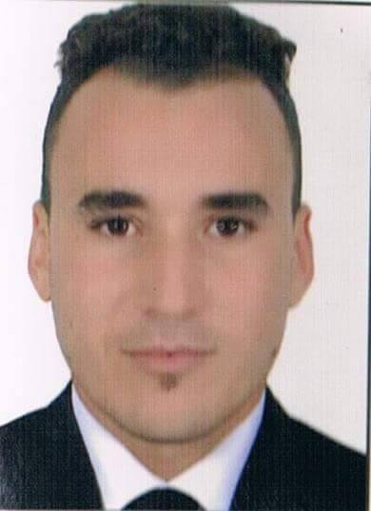

ABDERRAHIM.365708@2freemail.com

PERSONAL FORMATIOAN

FULL NAME ABDERRAHIM

EDUCATION

2011-2012 BACCALEUREAT
2013-2014 DIPLOMA OF TECHNICAL WAITER RESSTAURRANT ON
ISTA – FEZ

WORK EXPERIENCES

- Mounth stage on hotel IBIS-FEZ
- Mounth stage on hotel SAHRAI -FEZ
- Extra work on hotel BARCELO-FEZ
- Extra work on hotel SAHRAI-FEZ
- 2014-2015 : 6 mouth work on restaurrant PLATANE-IFRANE
- 2015-2016 : year work on restaurrant LUIGI-FEZ

LANGUAGES

  - Arabic : mother language
Anglais: advanced level
French : advanced level

