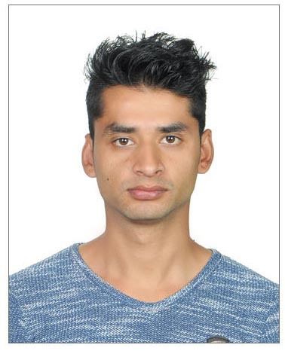Roshan
Roshan.365710@2freemail.com

Objectives:
To pursue a career in an organization which provides a challenging work environment and allows me to grow both professionally and as an individual.
Special Strengths:

- Good interpersonal skills
- Positive mental attitude
- Understanding and adjustable
- Ability to grasp information easily
- Developed ability to work in fast paced atmosphere
- Maintained excellent customer relation well
- Effective developed telephone communication skills
- Ability to follow instructions well

Professional Skills:
- Self-Correspondence
- Customer service skills
- Human resource
- Computer skills
Employment History:
Worked as a waiter in Namaste Nepal Hotels & Apartment from 1st july 2015 till 31st December 2016
Responsibilities
- Provide excellent customer service that promote satisfaction
- Greet customer and present menu
- Make recommendation or share additional information upon request
- Take and serve food/drinks orders and up-sell any additional products
- Arrange table setting and maintain tables clean and tidy
- Check products for quality and correct any problems that keep them from enjoying their meal/drink
- Delivery checks and collect payments
- Cooperate with all serving and kitchen staff
- Follow all relevant health department rules/regulations and all customer service guidelines
Education:
- Computer Basic course
- Buddha Academy
- Saurya International H.S. School
- B.B.S. Nasa International Collage

Personal Profile:

Date of Birth: July 31, 1991
Nationality: Nepali
Marital Status: Single
Height: 5”9’
Religion: Hindu
Sex: Male
Visa satatus: Visit visa
Language: English, Hindi & Nepali

I would like to thank you for any consideration you may give me and would appreciate an opportunity to meet you and certify that the above information given are true and correct to the best of my knowledge and belief.
Sincerely Yours,

