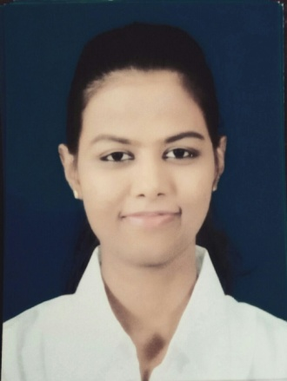
Joanne
Joanne.365723@2freemail.com
Currently I am in Dubai on a 3 months Visit Visa
VISA Expiry Date: 06th of June 2017

OBJECTIVE:
To display proactive hospitality through positive personality with both guest & co-workers. To gain a challenging position in an organization where I could execute my duties brilliantly while my skills and experience will be utilized with opportunity for carrier growth.
EXPERIENCE

- Receptionist trainee – Front office – Paradise beach hotel
Negombo Sri Lanka – August 2015 – December 2015
- Telephone Operator – Front office – Heritance Negombo
Negombo, Sri Lanka – January 2016 – February 2017

Job responsibilities:
- Answering internal & external phone calls and connecting calls to guest and hotel associates while following the brand standards
- Build & maintain a good reputation with guest and associates.
- Strong communication with sister departments, mainly with housekeeping,
reservations & bell desk.
- Attend departmental communication meetings and training sessions.
- To maintain a professional appearance.
- In case of fire alarm or false alarm act according to the hotels emergency procedures.
- Be up to date with all the hotels brand programmers & offerings.
- Promote the hotel generally when in conversation & to be aware of outlet offerings, daily functions, events, VIP & group arrivals.
- Receiving faxes & distributing them on time to the recipient.
- To ensure a smooth handover to the next shift.
- Answering Internal And External phone calls
- Handling Guest Request and complaints
EDUCATIONAL QUALIFICATIONS
• St Joseph Kanishta College, Negambo – Grade 1 – Grade 5
2000 – 2004
• Negambo South International – Grade 6 – Grade 9
2004 - 2010
• Sri Gnanodaya Isuru Divulapitiya – Grade 9 – Grade 11
2010 - 2012
EXTRA CURRICULAR ACTIVITIES
Sports
- Participated in the school netball team since 2007 – 2010
- Participated in athletics sports meets, high jump.

SKILLS
- Participated for debate competition as a team leader at Negambo south international school in October 2010
- Awarded first place in creative writing at the Divulapitiya educational division for the annual English competition in 2012.
- Awarded first place in creative writing at Minuwangoda education zone, annual English competition.
- Awarded first place in creative writing at Minuwangoda education Zone, annual English competition.

INTERESTS
- Excellent personal presentation & interpersonal skills
- Passion for exceptional customer service.
- Profound ability to ensure that the highest standards of hospitality are established.
- Have a good knowledge of computer literacy.
- Innovative & proactive.
- Love to meet new people and socialize.

PROFILE
Date of Birth : March 31, 1994
Gender : Female
Civil Status : Single
Citizenship : Sri Lankan (Dutch Burgher)
Religion : Roman Catholic

