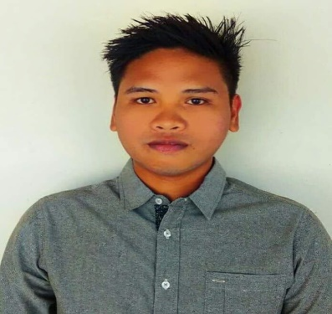
JEFFERSON
JEFFERSON.365738@2freemail.com

OBJECTIVE:
To be a part of your highly recognized and respected company where I can apply my knowledge, special skills, and experiences for the attainment of its vision and mission. Also, to continuously seek ways and means to learn more and to gain further relevant trainings to improve my craft, and to be able to develop my competencies to the fullest.

EDUCATIONAL BACKGROUND:
TERTIARY : Diploma Information Technology 2012-2016 : System Technology Institute (STI) Boquig, Bantay Ilocos Sur
: System Technology Institute (STI) : Burgos St, Vigan City, Ilocos Sur
Bachelor Science in Computer Science 2009-2010
: Quezon City Polytechnic University San Bartolome, Novaliches Quezon City Certificate in Computer Hardware Servicing
SECONDARY : Batch 2009 : Ilocos Sur National High School Gomez St., Vigan City, Ilocos Sur
PRIMARY : Batch 2005 : Pangada-Cabaroan Elementary School Santa Catalina Ilocos Sur
QUALIFICATIONS/SKILLS:
- Knowledgeable in Microsoft Office Applications.
- Know basic CCTV Installations.
- Creating Multimedia Presentations.
- Microsoft Visual Basic.
- PC Troubleshooting , and Maintenance.
- PC Operation – Software Installation.
- LAN Configuration - Structured Cabling.
- Maintain Computer System.
- Reliable and Flexible.
- Honest and Trustworthy.
- Willing to undergo training and learn new skills.
- Ability to perform under pressure.
WORK EXPERIENCE:
Mike’s Department Store (March 20, 2016 – January 11, 2017)
Computer Sales Technician
- Performing computer installation and operating system configuration in designated networks.
- Customer service: Ability to serve and assist and communicate with different types of customer efficiently.
- Accept customer desktop and laptop systems in-store for repairs.
- Troubleshoot system or software and work with customers to determine needed hardware or software changes.
- Explained features to customers and offered advice on best-fit choices based on customer needs.
- Software installation and application support.
- We can also install cctv camera if customers buy in our store.
SEMINARS/TRAININGS ATTENDED:
- Technical Education and Skills Development Authority(TESDA)
Computer Hardware Servicing NCII (356 Hours) System Technology Institute )STI) P-Square Bldg. Boquig Bantay Ilocos Sur March to June 2011
- 19th STI National Youth Convention SOCIAL MEDIA & ME November 29, 2013 Camp John Hay, Baguio City
- Power Personality and Image Enhancement Seminar October 29, 2011 Max’s Restaurant, Vigan City Ilocos Sur
OJT EXPERIENCES:
- Department of Trade and Industry Judy Chiu,. Mabini St. Brgy. 1 Poblacion Vigan City, Ilocos Sur
- Discount PC Powered By: Best Value Micro Co. 2nd Floor Gilmore I.T Center Building No.8 Gilmore Avenue., cor 1st St. New Manila Q.C
- Netopia Internet Café Vigan Plaza, Ilocos Sur

PERSONAL DATA:
Date of Birth : May 25, 1993 Age : 23 Sex : Male Civil Status : Single Nationality : Filipino Religion : Roman Catholic

I hereby certify that the above information is true and correct to the best of my knowledge and belief.

