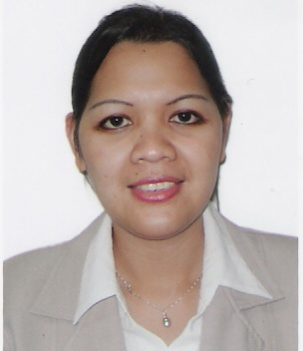

JOSEPHINE
JOSEPHINE.365745@2freemail.com

______________________________________________________________________________

OBJECTIVES:

To pursue a career in an organization that needs efficient and dependable personality where my knowledge, skills and experiences can be of service and in return be able to attain professional growth.

Has the ability to priorities and work well under pressure both as an individual and as a team player.

EDUCATIONAL BACKGROUND:

COLLEGE: HOTEL AND RESTAURANT MANAGEMENT
Western Mindanao School of Technology
Ozamiz city, Philippines

WORK EXPERIENCES:

SENIOR SALES ASSISTANT AND CASHIER
Online Electronics LLC
January 2006-January 15,2017
Abu Dhabi Mall, Abu Dhabi UAE

Job Description

- Greet the customer as they enter the shop.
- Assist the customer by demonstrating product knowledge about mobiles like Nokia, Samsung, Sony Ericsson, Blackberry, IPhones, Motorola, HTC and LG. For the cameras like Canon, Nikon, Sony, Olympus, Casio, Samsung and Canon & Nikon lenses, Gopro & camera accessories.
- Do the visual presentation regarding the products.
- Selling and activiting Etisalat and Du sim card.
- Selling Etisalat and Du voucher card.
- Responsible in merchandising the products.
- Responsible in handling cash and credit card transaction.
- Responsible in putting screen protection for mobiles and cameras.
- Making daily sales report

Dental Receptionis
Marina Dental Clinic
August 2005- December 2005
Salam St. Abu Dhabi, UAE

Job Description
- Entertained the patient and made opening personal profile
- Prepared all the instruments needed by the dentist
- Assisted the dentist during the operation

CASHIER AND SALES ASSOCIATE
Elim Monterey Foods (SAN MIGUEL CORPORATION)
Rizal Avenue, Ozamiz City Philippines
February 18, 1999- May 2005

Job Description

- Welcome and the assist the customer.
- Responsible in merchandising the product
- Take customers order
- Responsible in handling cash and credit card transaction
- Depositing cash to the bank
- Making daily sales report and doing monthly inventory

PERSONAL DATA

Birthday : October 9, 1980
Birth Place : Pan-ay, Clarin, Misamis Occidental. Philippines
Religion : Christian
Age : 36 years old
Status : Single
Nationality : Filipino
Visa Status : Visit Visa

I hereby certify that the above information is true and correct to the best of my knowledge.

