JETHA
JETHA.365756@2freemail.com

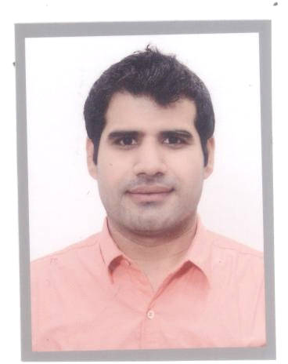
OBJECTIVE
- To service in progressive organization offering satisfaction, a challenging work environment and a vast opportunity for career development based purely upon achievement and results.
Personal information:
Date of Birth: 07/02/1983
Marital status: Single

Nationality: Pakistani
EDUCATIONAL QUALIFICATION : Passed HAAD Exam for Medical Practitioner 12-02-2015 .. 5 years experience as gp including 2 years experience in uae
Worked as a general physician unique care well medical center musaffah 37 from april 2015 to augst 2016., currently working at Al arab island medical center shabia 10,., from October 2016.,.
Degree / Diploma | From Date (dd/mm/yyyy) | To Date(dd/mm/yyyy) | University | Country
MBBS | 15 october 2003 | 30 dec 2010 | Liaquat University of Medical and Health Sciences Jamshoro | Pakistan
Intermediate | 2001 | April 2003 | Board of Intermediate Science Sukkur(BISE) | Pakistan
Matriculation | 1999 | Feb 2001 | Board of Intermediate Science Sukkur(BISE) | Pakistan
REGISTRATION - LICENSE DETAILS:
License /Registration issued by | Issuing Authority Country | Professional Title on License Attained | Issued date(dd/mm/yy) | Expire date(dd/mm/yy) | Country
Pakistan Medical and Dental Council(PMDC) | Pakistan | Registered Medical Practitioner | 26/02/2011 | 31/12/2015 | Pakistan

INTERNSHIP DETAILS
Hospital Facility Name | From Date (dd/mm/yyyy) | To Date (dd/mm/yy) | Major Subject
Abbassi shaheed hospital, CDGK. | 07/10/2011 | 06/04/2012 | General Medicine
Jinnah Postgraduate Medical Centre Karachi | 06/04/2011 | 05/10/2011 | General Surgery
WORK EXPERIENCE
Hospital Facility Name | Address of Employer | From Date (dd/mm/yy) | To Date (dd/mm/yy) | Job Title | Full Time/Temporary
Sakhi baba genral hospital & maternity home, pano-akil, sukkur | Sakhi baba genral hospital & maternity home, pano-akil, sukkur | 16/04/2012 | 15/04/2015 | Medical Officer | Full Time
Areas of strength:
- Strong interpersonal skills
- Ability to manage multiple cases
- Skillful in time managements ( in case of emergency)
- Resilient, punctual & quick learner
Language ability:
- English fluent
- Urdu fluent
Hindi fluent
Interests & Activities:
- I like to read different medical books and journals
- Play Cricket, Chess, Table tennis and other curricular activities.
Reference:
- Furnished upon request

