Curriculum Vitae
MAJID

MAJID.365763@2freemail.com

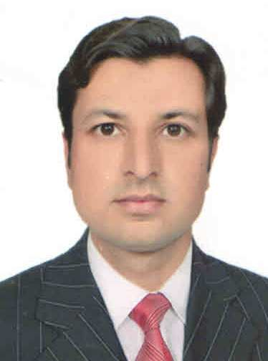

Career Objective

To serve a progressive organization in a competitive position where I can utilize my full potential with growth opportunity to highest policy and decision making position in all business functions and provide leadership.

Professional Qualification And Education

- Master of Commerce
- Bachlor of Commerce
- Intermediate
- Matriculation
- D.I.T

Work Experience

- 1 year computer and 2 year data entry operator in WHO.
- 2 years Monitoring in WHO.
- 1year Teaching in English medium school.

I.T Skills

- Good skills in the use of Microsoft Office including all its components;
- Adequate knowledge of Computer Hardware and different accounting software’s..
- Good knowledge of Internet and general computer usage

Personal

Date of Birth: March/20 /1992
Marital Status: Single
Nationality: Pakistani
Languages: English, ,Urdu & Pashto (Strong)

Reference

Will be forwarded, if required.

