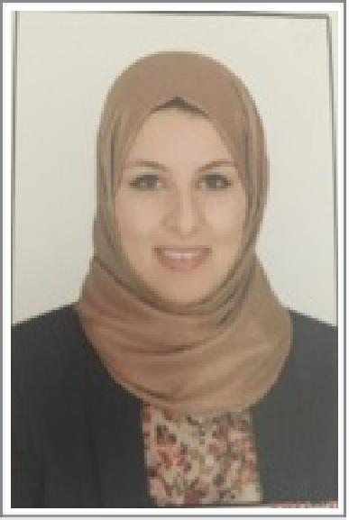

Alaa

Alaa.365765@2freemail.com

Professional summary :

Patient service-oriented pharmacist with American pharmacotherapy board and 4 years experi-ence between hospitals and chain pharmacies. Strong background in pharmacology and patient medication therapy management. Excellent track record of maintaining positive relationship with customer, pharmaceutical representative , manufacturers , medical professionals and insurance providers.
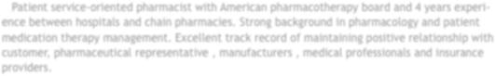

Academic Qualifications :

- B.Sc. of Pharmacy, Mansoura University on May 2012.

- American Board Certified Pharmacotherapy Specialist

- MOH licensed .

Experience:

Gamasa central hospital August 2013 to august 2015

Senior pharmacist

- Maintain drug inventory levels by ordering necessary medication and supplies, conduct monthly medication regimen review including recommendations and reports for the facility.

- Provide direction and oversight on all aspects of the acquisition, disposition ,handling , storage, and administration of drugs. Responsible for the distribution of all medications in the internal medical department.

- Train , coach , and motivate pharmacy trainee and ensure high levels of customer service and safety are maintained at all times.

- Mixed various pharmaceutical preparations according to written prescriptions.

- Communicated with all patients and staff in pleasant and professional manner .
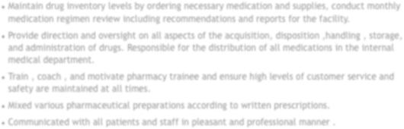

Sally pharmacies May 2015 to June 2016

staff pharmacist

- Accurately dispensing drugs to patients according to a doctor’s prescription. Checking prescrip-tions for errors & making sure they are appropriate for patients.

- Measuring, packaging, labelling and recording medications issued to patients. Instructing patients on how to use medications, possible side effects and storage.

- Answering questions from patients on medicines and cosmetics.

- Contacting and working closely with other healthcare professionals.

- Managing and resolving complaints.Communication with customers sympathetically and support-ively, giving private consultations when required.
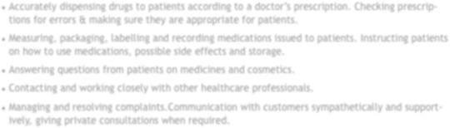

Ashraf Erfan pharmacies from September 2012 till December 2012

Associate pharmacist

- Entered new patient profiles and prescriptions into medication input software system.

- Communicated directly with doctor’s offices via telephone, fax and email.

- Provided friendly customer service at prescription drop-off and pick-up counters.

- Worked closely with senior pharmacist and used medication input software to safely and accu-rately dispense medication

- Accurately recorded compounded products and prepared appropriate labels.

Practical Training:

- Trained at Jean Coutu pharmacy in Canada on April & May 2016.

- Trained at Lifeline Hospital in Abu dhabi from January 2013 till May 2013.

- Trained at Ashraf Erfan Pharmacies in 2010 and 2011.

Personal skills:

- Hard worker, ambitious , creative , responsible , self-motivated.

- Having excellent communication skills.

- Sharing in social activities and charity programs.

Languages & Skills:

Languages:

- Arabic: Native speaker.

- English: Very Good.

- French : Neveau 4.

Computer skils:

- Microsoft Package: Excellent.

- Internet Skils: Excellent.

References will be available upon request

