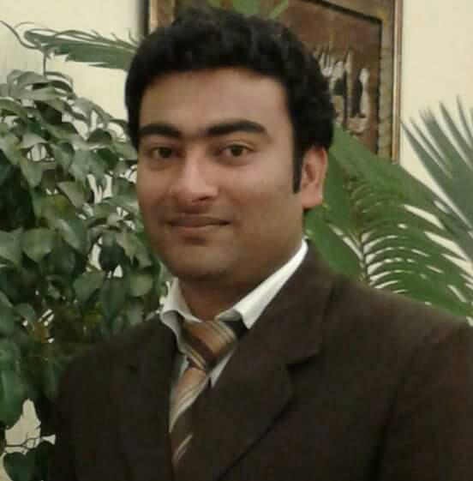

SYED
SYED.365776@2freemail.com
Career Objective
To obtain high level of excellence in the growth oriented Geological Organization and to utilize myself as a resource for kind of challenging jobs by upgrading my knowledge and skill from time to time. To be epitome of creativity, team work and intellectuality. An enthusiastic hard worker skilled in Geology; Seeking a position offering career opportunities for Personal Contribution and professional growth utilizing my technical knowledge in the Geological & Geo-technical field
Qualification
Bachelor of Science (BS) in Applied Geology from University of Azad Jammu& Kashmir (Muzaffarabad) Pakistan with 3.40 CGPA out of 4

MAJOR SUBJECTS:
Geotechnical Engineering | GIS (Arc View)
Engineering Geology | Seismology
Structural Geology | Hydrology
Petroleum Geology | Plate Tectonics
Petrology | Geochemistry
Mineralogy | Micropaleontology
Well Logging | Geophysics
Field Geology | Paleontology
Fielgeology | Geomechanics

Degree | Session | Board /University | Division/CGPA
B.S  (Geology) | 2012-2016 | University of Azad Jammu & Kashmir | 3.40/4.0 CGPA
F.Sc  (Pre-Engineering) | 2010-12 | Superior College Sialkot | 2nd Division
Matric (Science) | 2009 | Harvard Grammar High School Sialkot | 2nd Division

working Experiences

Soil and Rocks identifications

3 months’ experience in the field study/identify the rocks/marbles and soil investigation.
3 months training in Oil and Gas Development Company Limited.

CONFERENCES ATTENDED

PAPG Technical Workshop on “Hydrocarbon Exploration Techniques” at Oil and Gas Training Institute, Islamabad.

lANGUAGES

Urdu, English & Punjabi

Reference

Available on request

