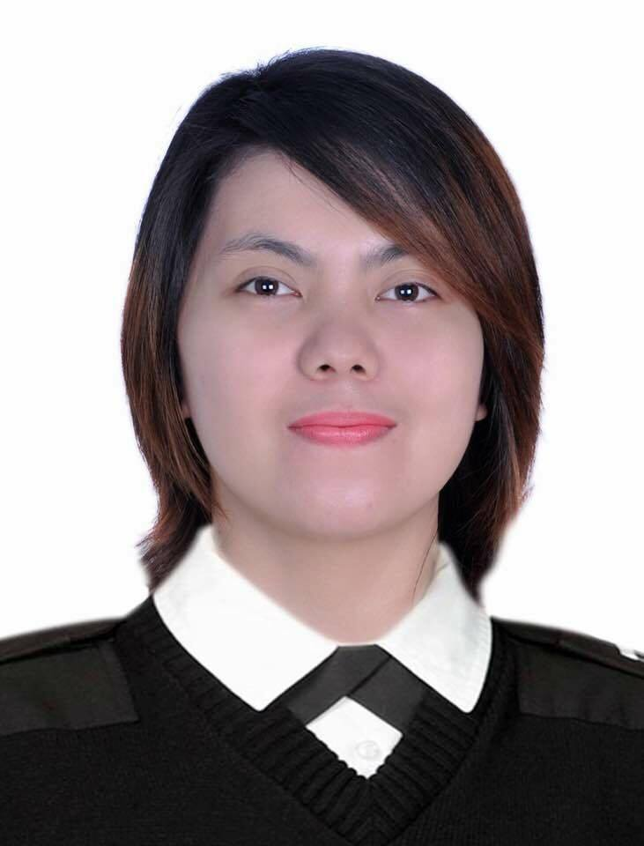
JAMIE
JAMIE.365780@2freemail.com

OBJECTIVE:

- To share my knowledge and to enhance my capability to do particular job or task that may give.
- To obtain work experience that offers new opportunities where I can expand my knowledge and skills.
- To impart my knowledge and skills in a way that meet the vision mission and objectives of company I serve.

PERSONAL STRENGTH

Excellent in terms of customer support service (with certificate)

Ability to prioritized and remain focused on the presence of an issue.

Work well without supervision
- Skilled at learning new concept quickly while working well under pressure.

EDUCATIONAL ATTAINMENT:

TERTIARY EDUCATION
Bulacan State University
Bachelor of Industrial Technology
Major in Computer Technology
City of Malolos, Bulacan Philippines
2009 – 2012

SECONDARY EDUCATION
Tiaong National High School
Pulong Gubat, Guiguinto, Bulacan
2005 – 2009

ELEMENTARY EDUCATION
Pulong Gubat Elementary School
Pulong Gubat, Guiguinto, Bulacan
1999 – 2005

Language/Dialects Spoken: Tagalog and English
AFFILIATION

2009 – 2012 Association of Computer Technology Students Member

CERTIFICATION

- Essential Food Safety Record of Attendance
Abu Dhabi, United Arab Emirates
April 27, 2015
- Certificate of completion in Customer Service Workshop
Dubai United Arab Emirates
July 7, 2015
- Basic food Hygiene Training Course
Dubai United Arab Emirates
February 27, 2014
- Defensive Driving Lesson
(Beginner Course)
October 21, 2013 – October 31, 2013

On-The-Job Training
Tollways Management Corporation
Sta. Rita, Guiguinto, Bulacan
Office Assistant
November 22, 2011 – March 12, 2012

WORK EXPERIENCE:

Sheraton Abu Dhabi Hotel & Resort (ADNH)
Arabian Desert Tours & Safari (Travel&Tourism)

Abu Dhabi, United Arab Emirates
Hotel Sales Representative/Team Leader (Travel & Tourism)
February 04, 2017 Up to Present
NATURE OF FUNCTIONS:

- Develop a strategy the team will use to reach its goal
- Provide any training that team members need
- Communicate clear instructions to team members
- Listen to team members ‘ feedback
- Monitor team members’ participation to ensure the training they are being provided is being put into use, and also to see if any additional training is needed
- Manage the flow of day-to-day operations
- Create reports to update the company on the team’s progress
- Distribute reports to the appropriate personnel
- Customer Service Skills: The customer is always right. You will need to able speak in a friendly way to guests and potential guests, listening to their needs and helping communicate options for them.
- Communication Skills: You will need to speak to customers about a Tours different features, and answer any questions they might have
- Flexibility: You might have to work long hours, nights or weekends.
- Persistence: Not every guests is going to be a sale. Being able to bounce back if you lose a sale will be key for this job.
Le Boulanger
Abu Dhabi, United Arab Emirates
Headwaiter/Captain
March 31, 2016 up to Present

Burger King (Yas Mall)
Abu Dhabi, United Arab Emirates
Cashier/Kitchen Crew/ customer service affiliates
February 26, 2014- February 26, 2016
NATURE OF FUNCTIONS:
- Greeting Customer
- Taking the order exactly
- Ensure payment are being collected
- And Giving orders completely
- Serving food and waiting on large groups of people
- Assist Customers and Complaints

Tollways Management Corporation
Toll Teller
Manila Philippines
March 19, 2013- October 21, 2014
NATURE OF FUNCTIONS:
- Assist Customer Service and Public Announcement
- Handle All kinds of Vehicle transaction and customer complaints
- Toll teller
- Receive and count daily inventories of cash
- Point of Sale

LBC EXPRESS
Stall #8-A 1/F Graceland Mall
Mac Arthur Highway
Malolos City, Bulacan Philippines
CASH TELLER/ CASHIER
January 2012 – January 2013

NATURE OF FUNCTIONS:

- Cash Checks and pay out money after verified that signatures are correct, that written and numerical amounts agree and that accounts have sufficient funds.
- Receive checks and cash for deposit, verify amounts, and checks accuracy of deposit slips
- Balance currency, coin and checks in cash drawers at ends of shifts and calculate daily transaction using computers, calculators or adding machine.
- Examine checks for endorsements and verify other information such as dates, bank names. Identification of the person receiving payments and the legality of the doc.
- Count currency, coins, and checks received by hand or using currency counting machine,
To prepare them for deposit or shipment to branch banks

