CURRICULUM VITAE

KARTHU
KARTHU.365783@2freemail.com

Professional Experience:
June 2014 to August 2016: SNEHA Diagnostics, Varkala, Trivandrum, Kerala.
Duties and responsibilities:
- Maintains a good relation with colleagues and patients
- Ensure the quality control of lab procedures.
- Supervising a team of lab technicians.
- Performing and interpret the lab tests.

Diagnostic Testing:
- Hematology
- Biochemistry
- Microbiology
- Serology
- Clinical Pathology
Proficient in operating:
- Biolis .24I
- Horiba hematology analyser
- Erba semi automated biochemistry analyser
- Statfax semi automated biochemistry analyser
- Mispa semi automated biochemistry analyser
- Easylyte electrolyte analyser

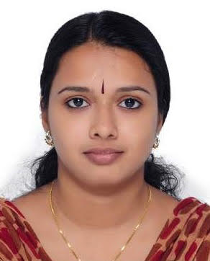
PERSONAL DETAILS
DOB : 18-07-1990
Sex : Female
Nationality : Indian
Marital status : Married
DHA Examination details:
Data Flow Reference
DHA Eligibility Id. :
Educational Qualification : BSc MLT (Kerala University)
Pass out May 2014
Computer knowledge : MS Office
Language known : English, Malayalam, Hindi
Declaration,
I hereby declare my above data is true to the best of my knowledge.

