CURRICULUM VITAE 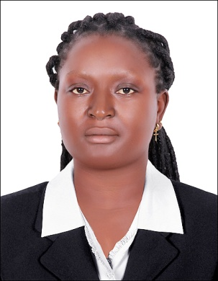
ODETTE.365788@2freemail.com

PERSONAL DETAILS:
NAMES: ODETTE
POSITION DESIRED : HOSTESS/GUEST ATTENDANT

CAREER OBJECTIVES
PERSONAL ATTRIBUTES
- Honest person with good communication and interpersonal skills.
- Consummate and knowledgeable hotel hostess professional with extensive experience in superior guest relation .excellent customer service professional with above-average social and interpersonal communication skiils .two years of hotel hostessing experience wth extensive knowledge of hotel and front desk operations
- CORE QUALIFICATIONS
- Terrific guest assistance upon arrival
- knowledgeably provide information about local attractions and events
- Courteous treatment of all guests
- Skilled problem solving abilities to address concern
- friendly and professional greeting of arriving guests

Le meridien Hotel, Douala, Cameroon Jan 2012- Jan 2014
Positon: RECEPTIONIST
Duties and Responsibilities
- Answer phone calls and make reservations.
- Welcomes clients into the hotel and clarifies their inquiries
- Provides every customer with an outstanding service maintaining good product knowledge and every aspect involves in making the guest satisfy.
- Suggest rooms for clients depending on the types of rooms
The client wants.
- Greeting guest upon arrival and completing check-in procedures
- Receives incoming documents and register them.
- Communicate customer request to management
- Create a conducive and friendly atmosphere for all clients.
- Accurately administer front desk activities.
- Immediately communicate guests concerns to management as needed
- Keeping the front desk area clean and organised
- Answer room service calls and provide orders to kitchen staff .
- Provide information about local eateries and current event and entertainment options
BLUE PEARL HOTEL CAMEROON
POSITION:RECEPTIONIST
DUTIES AND RESPONSIBILITIES
- answer phone calls and book appointments for customers
- greeting and directing customers to get the services they want
- being attentive to clients at all times
- resolving any customer complains
- giving sales presentations to potential customers explaining the benefits of our products
- answering any queries from customers
- taking cash and credit card payment from clients
- keeping the environment always clean
EDUCATIONAL QUALIFICATION
ORDINARY LEVEL CERTIFICATE
ADVANCE LEVEL CRTIFICATE
HIGHER NATIONAL DIPLOMA IN BANKING AND FINANCE

REMARKS; I DECLARE THAT THE ABOVE INFORMATION GIVEN IS TRUE TO THE BEST OF MY KNOWLEDGE.
REFERENCE TO BE FURNISH UPON REQUEST.

