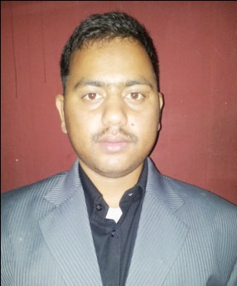
CURRICULUM VITAE
Laxman Laxman.365797@2freemail.com
Objective
To Work in a progressive organization which could help to enhance by working capabilities, professional skills, business efficiencies and provides me exciting opportunities to utilize my skills and qualification to produce result fidelity

PROFESSIONAL SKILLS

- Hardware Maintenance
- Team Leadership
- Dynamic Web Design (Wordpress, HTML , PHP(Laravel),Bootstrap )
Organization I Worked With
- Universal Technical Group , Damak-13
- UniTech Solution, Birtamod-13
Experience
- 2 years of Experience as Development Officer and IT Assistance.
(Responsibilities are Web development, Supervise the Developers, Theme edit, Responsive Design, PSD to HTML Conversion etc.

- 6 months of Experience as Computer Operator in UniTech Solution.
(Responsibilities : Manage Computer Lab, Office Network, System Analysis etc.
Skills
- Microsoft Office (word, excel, PowerPoint, Access etc.)
- Knowledge of Photoshop
- Operating system (Linux and windows)
- Knowledge of Hardware and Networking
- Proficiency in the troubleshooting and resolution of all client queries.
- Good problem solving skills along with the ability to work under pressure.
- A methodical and structured approach to problem solving.
- Understanding of PC hardware setup and configurations.

Qualification Summary
- BSC.IT from Sikkim Manipal University, India. (Learning Center in Nepal is College For Professional Studies) " College For Professional Studies is publicly Known as Lord Buddha Education Foundation (LBEF)."
- Demonstrated skill in managing change and maintaining flexibility in a variety of challenging environments.
- Ability to work in diverse teams and to communicate well with others.

Education
- Bachelor of Science in Information Technology (Bsc.IT) – August 2014 :Sikkim Manipal University (SMU)
- 10+2 Science, Completed year – 2011 :Higher Secondary Education Board (HSEB)
- School Leaving Certificate (SLC), Completed Year – 2009

Certification & Trainings:
- Web Development Training (PHP, MYSQL, HTML, CSS) From Milestone Institute Pvt. Ltd.
- Advance Java Training Course From Broadway Infosys Nepal

Personal Information
Gender: Male
Temporary address: Abu Dhabi , UAE
Nationality: Nepalese

I hereby declare that above mentioned are true & best of my knowledge.

