SITA
SITA.365800@2freemail.com

RESUME

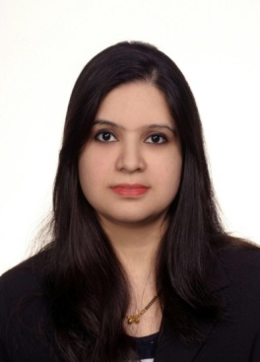
OBJECTIVE:
To obtain an excellent opportunity where my skills, experience and professionalism can be utilized for the benefit of my employers and will enhance my career path for further growth and development through outstanding performance.
Work Experiences
- Aryan Computers. India (May-2014 Nov-2014)
Position: computer teacher
- Excel
- Word
- PowerPoint
- HTML

- Hind institute of information And technology, India (Nov-2008 to Jan-2014)
Position: receptionist, student co-ordinator and data entry operator
- Serve visitors by greeting, welcoming, directing and announcing them appropriately
- Answer, screen and forward any incoming phone calls while providing basic information when needed
- Update appointment calendars and schedule meetings/appointments
- Identify and resolve student concerns by acting as a mediator.
- Assist new students through admission processes.
- Maintain student contact notes and records.
- Entering data accurately onto computerised databases & Excel spreadsheets.
- Maintain student records, result, fees, and admission session.

- Tata Photon. India (May-2008 to Jul-2008)
Position: Telecaller/Telesales
- Contact potential or existing customers to inform them about a product or service using scripts
  - Answer questions about products or the company
  - Ask questions to understand customer requirements and close sales
  - Enter and update customer information in the database
  - Take and process orders in an accurate manner.
  - Keep records of calls and sales and note useful information

- New Little Star High school, India (Aug-2006 to Mar-2008)
Position: Teacher (junior classes)
- English
- Hindi
- computer

EDUCATIONAL QUALIFICATION
- Master’s degree in political science from Karnataka State Open University in 2011, India
- Bachelor degree in Arts from Jammu University in 2006, India
TECHNICAL QUALIFICATION
- One year diploma in Computer Software from HIIT, Jammu India
Strengths:
- Good educational background with effective communication skills.
- A self-starter, motivated, flexible and adaptable in all circumstances.
- Capable of working long hours.
- Excellent motivational & organizational skills.
Hobbies:
- Listening music.
- Watching movies
- Travelling and meeting people of different culture

Languages:
- Hindi
- English
- Nepali

Ref References
- Sheikher Dhar sales manager 0502538533
- Rakesh Koul manager Sea View Hotel 0501852011
erences:
sheik

