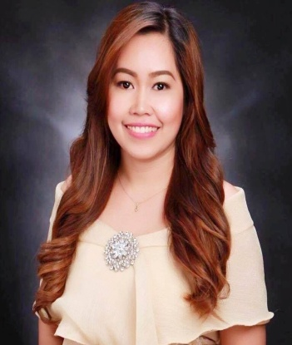
CRISTINA
CRISTINA.365810@2freemail.com
Objectives:
To be part of fast pace industry wherein I can apply new learning techniques, fresh ideas on human relations and to exhaust my talents and abilities.
WORKING EXPERIENCES:

Company : Tactical Business Services
4th Floor JMT Corporate Condominium #27 ADB Avenue,
Ortigas Center, Pasig City
Job Title : Customer Service
Date : April 29, 2016-February 28, 2017
Job Description : 1. Verifying an incoming and outgoing orders.
2. Processing cancellation if necessary.
3. Providing exceeded customer satisfaction.

Company : Career Hunter Recruitment Solutions (On the Job Training)
3rd Floor Polar Center Mandaluyong City
Job Title : HR Associate
Date : January 25, 2016 – Feb 29, 2016
Job Description : 1. Sourcing Applicant/Candidates for the clients.
2. Encoding and validating the resume of the clients.
3. Interviewing applicants.

Company : Arellano University School (On the Job Training)
Job Title : Guidance Counselor Assistant
Date : December 2015-January 2016
Job Description : 1. Assist on how the Guidance Counselor evaluate the students
and professors.
2. Liable for the tally evaluation of the students and professors.
3. Conducting an interview to the students.

Company : Metro Psychiatry Facility (On the Job Training)
Job Title : Assistant Occupational Therapist
Date : October 2016-December 2016
Job Description : 1. Facilitate an activity to the patients for them to have a
socialization.
2. Administered a Psycho Test to the patient and evaluate it.

PERSONAL DATA
Birthday : April 14, 1981
Birth Place : Koronadal City, Mindanao
Civil Status : Single
Height : 5’
Weight : 110lbs
Religion : Catholic

EDUCATION

College : Bachelor of Arts in Psychology
Arellano University Pasig City
June 2013-March 2016 (Graduated as Cum Laude)
Secondary : Koronadal Comprehensive High School
1995-1999
Elementary : Marbel 1 Central Elementary School
1988-1994

SEMINAR ATTENDED

Human right force Disappearance
Arellano University-Pasig
December 6, 2013

Not to Bullying skill of Psychology student
Arellano University-Pasig
January 30, 2014
Workplace Bullying
Arellano University-Pasig
June 26, 2014

Research and Method
Arellano University-Legarda
February 11, 2015

SKILLS
- Strong interpersonal skills
- Can work under pressure
- Computer Literate

I hereby signed that the above information is true and correct to the best of my knowledge and belief.

