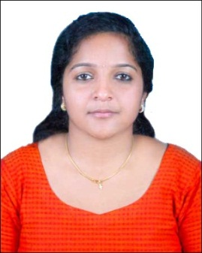

CURRICULUM VITAE

LIGI

LIGI.365820@2freemail.com

OBJECTIVE

I would like to associate with an organization which gives me an opportunity to explore my talent in the areas of programming, analysis, testing and such areas in I.T with continuous learning for self and development of the organization.

EXPERIENCE

- Worked as JAVA Developer in Claveland Technologies Pvt.ltd

KEY ROLE

- Analysis of product based on the requirements.
- Supervising the finished product produced.
- Prepare the phases of the testing, review and contribute to the test-plans, as well as analyzing, reviewing and assessing requirements and design specifications.
- Decision making power regarding requirements .

EDUCATIONAL PROFILE

School

2008; St. Mary’s Girls high School, Kottayam, India

High School

2010; Govt. higher secondary School, Kottayam, India

Graduation

2013; Ettumanoorappan College; Mahatma Gandhi University; India

Post Graduation

2016; SJCET; Mahatma Gandhi University; India

INTERN DETAILS

I have successfully completed six month intern training in the below specified reputed industries:

- Claveland Technologies( Kerala)
- Logic Software Solutions( Kerala)
- Amariz Logic Software Solutions( Kerala)

ACADEMIC AREA OF INTEREST
JAVA, PHP, .NET, C++.

PROJECTS UNDERTAKEN

Title : Detection and Prevention Of Flooding Attack Using SVM
Technology.
Description: It’s an implementation of a technology called IDS Tec-hnology based on an IEEE paper. The main aim of this project is to detect the node or device which makes flooding in a MANET (Mobile ad-hoc network) and prevent the flooding attack.
Platform : JAVA, My SQL.

Title : Customer Response Management(CRM).
Description: CRM which is capable of managing all the activities and interacting with the customer and also solving their complaints.
Platform : PHP, Ms SQL.

RELATED SKILLS

- Knowledge in UNIX, LINUX.
- Conversant with the understanding of different aspects of Operating Systems.
- Conversant with the basic knowledge of networking.
- Strong in Software Development Life Cycle (SDLC) and Software Testing Life Cycle (STLC).

ACHIEVEMENTS AND PARTICIPATIONS

- Association coordinator (2010-13) of Department of Computer Science and Applications at Ettumanoorappan College, Ettumanoor.
- Have participated in CAMEO 2015 IT Fest and got second prize for paper presentation.
- Got First prize for elocution in college level.

PERSONAL PROFILE

Date of Birth: 23-01-1993

Religion: Roman Catholic

Nationality: Indian

Marital status: Single

Visa status: Visit visa

DECLARATION:

I hereby declare that all the above information are true and correct to the best of my knowledge and belief.

