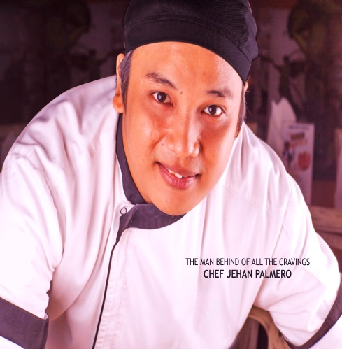
Jehan

Jehan.365846@2freemail.com
CAREER OBJECTIVE:
To work in a good company where I can contribute the best of my ability and skills and that will develop my profession by combining my educational background with addition of practical experience. I am willing to undergo further training to compliment my capability and motivation to assume such responsibility.

JOB DESCRIPTION:
• Monitors and guides staff and prepares weekly work schedules for all kitchen personnel in accordance with staffing guidelines and forecasted labor costs.
• Supervises food production, maintains standards and improves the image of the operation at all times and applies all skills required for service.
• Formulates clear statements of objectives in order to maintain an excellent reputation.
• Develops action plans aimed to introduce new items for all staff and carries out daily briefings with production staff in his kitchen.
• Reduces wastes and maintains controls to attain forecasted food and labor costs.
• Assumes full responsibility for the costing of all food items produced and oversees the proper storage and receiving of food items throughout the operation.
• Maintains high standards of hygiene and cleanliness at all times.
• Controls, monitors and supervises the monthly inventory

WORK EXPERIENCE:
Fraiche Café And Bistro
(Italian, Greek,French,Asian)
Head Chef
April 2015 up to present
Sr. Sous chef
April 3, 2014-April 2015
Byblos Hotel Dubai Internet City
Aldente Italian Restaurant
Menu Planner, Haccp Coordinator,
Area: Salad/ Main course/pizza /desserts
March 15, 2013 – April 1 2014
Radisson Blu Media City
Main Kitchen/Room Service/ Icon Bar, Restaurant.
Ala carte
Chef De partie
October 2011 – February 2013
Certo (Italian Restaurant)
Pasta/Salad/Main Course
January-September 2011
Dubai International Hotel (Airport)
Gallery (terminal 3 main kitchen)
(Shift in charge) Aug 2010- December 2010
. Open Show Kitchen (terminal 1 main kitchen)
(In charge of open alacate and buffet May 2008- Aug 2010
. Irish Village Alacarte
(Shift in charge) Sept. 2007-May-2008
(Commis I)
. Lounges/First Class/Business Class (passenger lounge)
(In charge) Aug. 2006- Sept. 2007
(Commis I)
Hotel Sofitel Manila
Hardin Lounge (commis I)
(Breakfast Chef)Aug 2005-June 2006
Grand Blvd. Hotel Manila
Courtyard Grill
Alacarte (commis I) July 2003- July 2004
Chowking Food Corp. (Manila)
Cook General May 2002- Nov. 2002

SEMINARS ATTENDED:

. Basic HACCP
. Basic Food Hygiene
. Basic Telephone Etiquette
. Person In-Charge in food safety Dubai Municipality (PIC) HYGEA Level 3 High field
. HACCP Level 3 High field
EDUCATIONAL ATTAINMENT:
Bachelor of Hotel and Restaurant Management
Philippine Women’s University
March 2003(Graduated)

