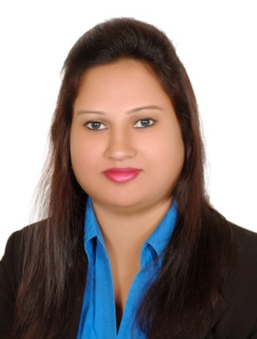

CURRICULUM VITAE

Marie
Marie.365898@2freemail.com
_____________________________________________________________________

OBJECTIVE

Quest to be employed in a work atmosphere that will build, develop and strengthen my skill sets to grow with the organisation along with its business imperatives which will give me a perfect professional as well as personal career.

SKILLS SETS

- Ability to work in an organisation with core competency and teach.

- Learning ability to constantly upgrade my skills.

- High level of integrity, passion, dedication and commitment.

- Ability to work under stress, pressure, performance and goal oriented work culture.

- Adaptability to situations, flexibility to change and vision to grow with the organisation.

EDUCATIONAL QUALIFICATIONS:

SSC from St Ann’s high school
St Francis Junior Girls College
PPTT – Pre-primary teacher training
BA literature

Technical Qualification:

- Certified as a Voice and Accent Trainer, Soft Skills Trainer and Assessor

- Certified as a Professional Trainer, Evaluator and Learning Style Expert

- Certified in Training Methodology, Lesson Planning and Design from IQ Intelligent Training Pvt Ltd.

Work Experience:

1997-1999 : Worked for St Michaels High School (CBSE) as a Teacher

2003 - 2007: Worked for St Ann’s High School (ISC) as a Teacher.

2010-2011: Worked for St Ann’s High School (ISC) as a Teacher.

2012-2013: Free lanced for IQ and INTEQ BPO Services Pvt. Ltd as a Voice and accent, Communication Trainer.

2013-2015: COA Network as an English communication trainer.

February 2015- August2016: Worked for Frankfinn Airhostesses training institute as an English Trainer.

Training Activities

- Conduct Voice Accent training sessions
- English Grammar Classes
- Call Quality Checks
- Conduct group sessions
- Email Etiquettes Classes
- Interview Skills training
- Telephone Etiquettes and Listening Skills class room sessions
- Conduct feedback sessions (1x1)

Personal Details

Date of Birth : 10th March

Marital status : Married

Nationality : Indian.

Religion : Roman Catholic

Languages known : English, Hindi

HOBBIES AND INTERESTS:

Reading books, listening to music and Painting

