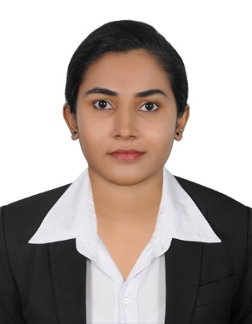
RAHNA
RAHNA.365900@2freemail.com

CAREER OBJECTIVE

To obtain a position in a company where I can enhance successful, challenging & exciting career while being able to dispense my maximum potential to the benefit of the organization at the same time acquiring knowledge on the road to success.

PROFESSIONAL EXPERIENCE

MIS Executive
2013-2014
Naba Traders (I) Pvt Ltd, Kerala

- Provide support and maintenance to existing management information systems(MIS).
- Update day to day reports such as purchase and sales in MIS software.
- Coordinating and updating with the existing micro distributors through calls and emails for regular updates and general co-ordination.
- Scheduling and coordinating business development meetings.
- Provide service level target to distributors and prepared variance reports such as forecast vs actual sale.
- To maintain records in accordance with current policies.
- Maintain confidentiality and observe data protection and associated guidelines where appropriate.
- Prepare daily reports and update the same to the manager.

Sales executive
2010-2012
DHL Express (I) Pvt Ltd, Kannur, Kerala

- Maintaining and developing relationships with customers via telephone calls and email. and listening to customer requirement and presenting appropriately to make a sale.
- Gathering market and customer information and negotiating the terms of an agreement and closing sales.
- Arrange meeting with potential customers to prospect for new business.
- Ensure appropriate and timely delivery of services.
- Make rapid calculations of costs to provide temporary quotations.
- Prepare sales reports by analyzing and summarizing information.
- Reviewing own sales performance, aiming to meet or exceed targets.

Office assistant
2009-2010
Alhind Tours&Travels, Malappuram,kerala

- Answering redirect general inquiries in person, by telephone or mail.
- Front office duties as well as administrative duties.
- Update and maintain databases such as mailing lists, contact lists and client information.
- Greet public and clients and direct them and giving best services.
- In the absence of other secretaries or receptionist, complete their necessary duties as delegated by office manager.

ACADEMIC QUALIFICATION

- Bachelor of arts in English classes from Indira Gandhi National Open University(IGNOU), SN College – Kannur -2013

PROFESSIONAL QUALIFICATION

- Diploma in Airport Management (Calicut Institution) Kannur –Kerala 2008-2009
- Training completed from Guiders Mission Tours and Travels, Cochin- 2009
Diploma in Travel & Tourism
Ticketing - Amadeus & Galileo
- Training completed from Calicut International Airport
- Computerized MS Office.

PERSONAL DETAILS

Date of birth: 22 Dec 1990
Marital Status: Married
Nationality: Indian
Languages known: English, Hindi, Tamil and Malayalam

REFERENCES: will be furnish on demand.

