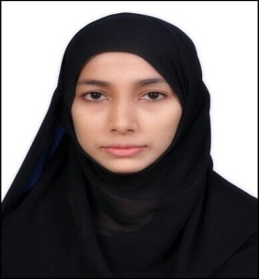
CURRICULUM VITAE

AMREEN
AMREEN.365920@2freemail.com

Objective:
To secure a position that will enable me to use my strong organizational skills, educational background and ability to work well with people and be a part in developing the organization that I work for and also to enhance and acquire personal growth.

Professional skills:
- Programming Languages : C,C++,JAVA

- Operating System : Windows XP/VISTA/7

- Computer knowledge related to: Computer graphics, theory of computation, design and analysis of Algorithms, computer networks, System software, Data Structure,unix.

Education Qualifications:

Course | Institution | University Board | % Marks & Year of passing
M.Sc(C.S) | Karnatak University,  Dharwad | Karnatak University,  Dharwad | 79 in 2014
B.Sc | M.M Arts and Science  College,Sirsi | Karnatak University,  Dharwad | 71.75 in 2012
P.U.C | M.E.S Pre University College, Sirsi. | PU College Board, Karnataka. | 56 in 2009
S.S.L.C | Don Bosco Institution, Sirsi. | Karnataka State Board | 85.60 in 2007

Experience:

1 year experience as a teacher in Jun 2015-16.
Excellent communication skill.

Project works:

Project: Project on corporate recruitment system.

Personal Profile:

- Course :MSc (CS)
- Date of birth : 16/09/1990
- Languages : English, Hindi.
- Nationality : Indian
- Marital status : Married
- Hobbies : Playing TT, Chess, Basket ball, Drawing

I hereby declare that the above mentioned information is true to the best of my knowledge and I have enclosed respective certificates as a testimony to the same.

******************

