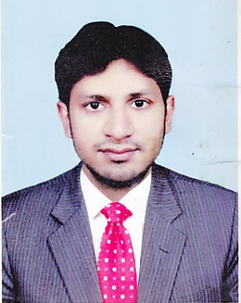
Muhammad

Muhammad.365935@2freemail.com

Objective

To contribute towards the growth and development of a dynamic organization, where opportunities to grow both personally and professionally are ample and where I can utilize my skills effectively and efficiently.

Professional Career Summery Accounts & Administration (3 Years)

- Working experience with “Muhammad Yawer Supermarket” as a “Data Entry Operator” from August 2016 To date
- One year work experience with “Hani Mall L.L.C” as a “Salesman” from July 2014 to June 2015
- One year work experience with “Hani Mall L.L.C” as a “Cashier” from July 2015
to June 2016

- Work Experience MUHAMMAD YAWER SUPERMARKET RAK, U.A.E
(My Job responsibilities are as under);-

- Research and obtain further information for incomplete documents
- Apply data program techniques and procedures
- Generate reports, store completed work in designated locations and perform backup operations
- Scan documents and print files, when needed
- Keep information confidential
- Respond to queries for information and access relevant files
- Comply with data integrity and security policies
- Ensure proper use of office equipment and address any malfunctions

- Work Experience HANI MALL Ajman, U.A.E
(My Job responsibilities are as under);-

- Handle cash transactions with customers
- Scan goods and collect payments
- Issue receipts, refunds, change or tickets
- Make sales referrals, cross-sell products and introduce new ones
- Resolve customer complaints, guide them and provide relevant information
- Greet customers when entering or leaving establishments
- Maintain clean and tidy checkout areas
- Keep reports of transactions
- Pleasantly deal with customers to ensure satisfaction

Academic Profile (All Degrees are attested from University, Board, H.E.C and Ministry of Foreign Affairs)

Course | Specialization | University/Board | Passing Year
Matriculation | Science | Board of Intermediate & Secondary, Education Faisalabad-Pakistan | 2010

Computer Skills

- Internet Searching
- Hardware assembling
- Networking
- Software and Window installation
- Photo Shop

Personal Information

Date of Barth: 1991-10-26
Place of Barth: Faisalabad
Nationality: PAKISTANI
Marital status: Single
Religion: Islam

Declaration

I hereby declare that all the above furnished details are true and correct to the best of my knowledge and belief.

