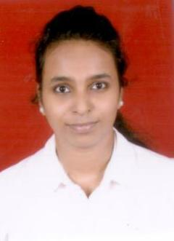
Name: Harshita
Harshita.365954@2freemail.com

PROFILE

My name is Harshita. I have just completed my MBA and PGPM in Marketing as my specialization.My objective is to be an astute learner and the best performer in the organization. So that I can build an innovative career in the esteemed organization by using my skills and other significant talents.

EDUCATIONAL QUALIFICATIONS

QUALIFICATION | YEAR OF  PASSING | SCHOOL/COLLEGE | UNIVERSITY/BOARD
M.B.A + PGPM | Pursuing (2015-2017 June) | FOSTIIMA Business School | Pondicherry University
Bachelor of Management studies | 2014-2015 | Bunts Sangha College | Mumbai University
H.S.C | 2011-2012 | M.L Dahanukar college of commerce | Mumbai University
S.S.C | 2009-2010 | Cardinal Gracious High School | Maharashtra State Board

1 ) INTERNSHIP

Company Name: ADORA GIFTS PVT LTD
Duration: 4 months
Designation: International Sales & Marketing

Key Responsibility Areas:

- Handled online International sales and marketing efforts of our company.
- Promoted products in International markets through B2B portals, along with team members and through email marketing and internet marketing.
- Achieved quarterly sales targets set by the company
- To keep track of all business emails and to follow up with the clients from inquiry to order and delivery to feedback.

2 ) INTERNSHIP

Company Name: DIALHEALTH PVT.LTD
Duration: 2 months
Designation: Marketing Intern

Key Responsibility Areas:
- Data Collection
- Data Management
- Handling purchase and sales records
- Stock Audit
- Field Work
- Handling Projects
ACHIEVEMENTS & AWARDS

- Organized events at college level
- Participated in Polio awareness Program of Rotary Club.
- Achieved 'B' Certificate in NCC (National Cadet Corps, 3rd Maharashtra battalion )
- Attended a conference on ‘International Research conference on Retail a great success”
- Attended a seminar on “Failure a stepping stone to success”
- Attended a conference on “Building the winning attitude”
- Participated in “NATIONWIDE CANCER CONTROL PROGRAMME”
- National Certificate in ‘MODULAR EMPLOYABLE SKILLS”

SKILLS

- Basic knowledge of computers,
- Microsoft office - MS Word, MS Excel, MS PowerPoint
- Knowledge of Internet Application

INTRESTS

- Travelling
- Dancing
- Listening Music
- Event organizing
- Social service

