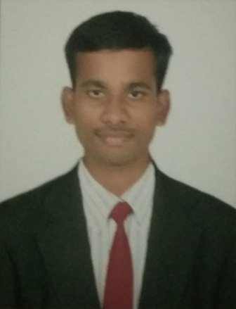

POLINAIDU
POLINAIDU.365965@2freemail.com

CAREER OBJECTIVE

To Working in a Challenging Environment that would utilize my over all abilities , and knowledge skills help my career growth in prosperous manner.

ACADEMIC QUALIFICATION

- Diploma in hotel management in AIM COLLEGE (2014-15) Vishakhapatnam.
- Intermediate (+2) from Board of Intermediate Andhra Pradesh, India, ( 2012-2014)
- S.S.C. or 10th by Board of Secondary School of Education Andhra Pradesh,( 2012)

WORKPROFILE

- April 2015 to Febraury 2017 working As a waiter at FOUR POINTS HOTEL Visakhapatnam, India.
RESPONSIBILITIES:
- Greets guests and presents them with the menu.
- Informs guests about the special items for the day and menu changes if any.
- Suggest food and beverages to the guest and also try to upsell.
- Performing basic cleaning tasks as needed or directed by supervisor.
- Filling in for absent staff as needed.
- Communicate to the guest and provide assistance with their queries.
- Maintaining proper dining experience, delivering items, fulfilling customer needs, offering
- Desserts and drinks, removing courses, replenishing utensils, refilling glasses.

SKILLS

- Learning new activities
- Internet Savvy
- Good command in English communication skills
- Internet explorer
- Strong analytical, problem solving, organizational ability

TRAININGS

PERSONAL STRENGTH

- Job Safety Training
- Make It Right Guest Service
- Basic Safety Training
- Monthly Hazard Critical Control Point (HCCP) Training
- Risk Assessment Training

- Enthusiasm
- Self motivation, capable to work in fast paced environment under pressure
- Ability to develop, propose and implement strategies and plans.
- Quick Learner

PERSONAL PROFILE

Date Of Birth : 11-04-1997
Gender : Male
Marital status : Single
Residency : Dubai.
Nationality : Indian.
Languages known : English, Hindi & Telugu.

