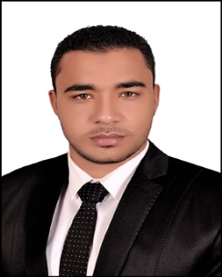

Mohamed
Mohamed.365968@2freemail.com

Career objective:
- Seeking a challenging position, that effectively utilizes my qualifications and improves my experience.
- Looking forward to join a progressive organization that offers opportunities for advancement.
- Ready and looking forward to improve my skills through different educational courses.

EDUCATION:
University: (2015) Bachelor of Commerce, Arabic Section, Damnhour University , Accounting department.
Grade: very good

Experience:_________________________________________________________________
Trainee Accountant at United for Auditing&Accounting(Dec2016_Mar2017)

Courses:

-ICDL

-ACCOUNTING ADVANCE

-COMMERCIAL EXCEL

-peachtree

-general english

Computer SKILLS:
- Microsoft Office Package (Word, Excel, Power Point)..

Language SKILLS:
- Arabic: Mother Tongue.
- English : Good (speaking, reading & writing).

COMPETENCIES:
- Self-motivated, ambitious and reliable.
- Hard working.
- Excellent in communication skills and a good team player.
- Work under pressure
- Able to meet deadlines and achieve required results.

