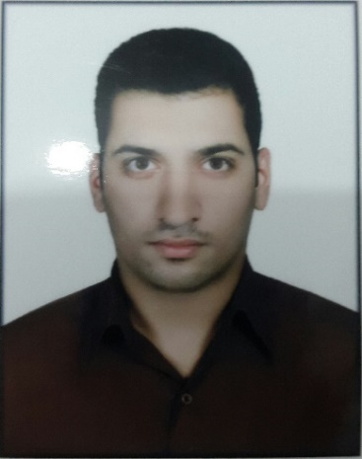
Profile
- Name: Saleh
Saleh.365970@2freemail.com

I read with interest your posting for lab job. I believe I possess the necessary skills and experience you are seeking and would make a valuable addition to your company.
As my resume indicates, I possess more than 5 years of progressive experience in the personal training field. My professional history includes positions such as karate coach as well as fitness instructor. My supervisor also relied on my ability to skills such as ms office, dominate in arabic english and farsi and excellent communication and managemant skills.
I have attached my resume for your review and I look forward to speaking with you further regarding your available position.

Education
Bachelor of Agricultural Sciences and Natural Resources Gorgan University of Agricultural Sciences and Natural Resources
- Plant protection specialty
Marketing Management Certification Entrepreneurship Branch Chamber of Industry and Mines and Agriculture of Iran
- 3 month training course in marketing management
Processing and Marketing Medicinal Plant Certification Technical and Professional Organizations of Iran
- 120 hours of training with 50 hours practical training
Karate Black Belt Certification Karate Board of Iran
- 5 years training

Career
- Secretary of the Scientific and Cultural Center at Gorgan University 2013 - 2016
- Secretary of the Scientific Board of Department of Plant Production 2012 - 2013
- Motivational Speaker in Entrepreneurial Group 2013 - 2016
- Personal Teacher ADSL and Microsoft office 2010 - 2015
- Assistant electrician 2008 - 2010
- Plant Protection Research Laboratory Operator 2013 - 2016
- Online Marketer 2010 – 2014 Consulting market and Producing constant for online markets
- Real State Agent and Consultant 2010 – 2011
- Construction Equipment Marketing 2008 - 2010
- Green House Marketing Manager 2015 - 2016 Production of Ornamental Plants, Fertilizer and Mushroom
- Stock Exchange
- Buy and Sell the Stock of New Companies in Market
- Personal Coach 2012 - 2015 5 years experience in karate

Skills
- Fluent in English, Arabic and Persian
- Fluent in Microsoft Office
- Fluent in SAS and R Statistical Analysis Software
- Updated Internet Skills
- Fluent in Hardware and Software Skills
- Excellent Brainstorm Ideas
- Excellent Presentation Skills
- Excellent Communication
- Good Experience and Skills in Researching
- Good Experience and Skills in Document Management
- Creative
- Adaptive
- Hard-working
- High Energy
- Fast Learner

