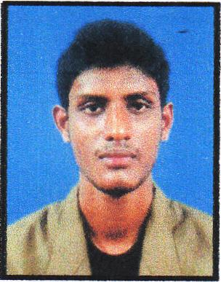
DINESH

DINESH.365974@2freemail.com

Career Objective
To acquire a challenging position in an organization in order to make a contribution of my work, time and effort toward the company and to work hard with full dedication for the achievement of organization objective under satisfying job contact, hence enhancing my skills and knowledge and to get an understanding of the practical applications in the field of work.
Personal Vision: To have a challenging career in corporate world and to be a successful professional.

Personal Details
- Date of birth : 21-07-1990
- Nationality : Sri Lankan
- Gender : Male
- Marital status : Single

ACADEMIC QUALIFICATION

Advance Level Examination–(2009)
- Sat for the examination

G.C.E Ordinary Level Examination-(2006)
- Qualified

Other Qualifications
- I completed international cookery course at Swiss Lanka hotel school, Sri Lanka.
- I completed Basic food preparation, city and guilds exam.
- I have followed a computer course at the Getaway institute Sri Lanka
- I have followed an English course (Diploma in English) at St. Anthony's Institute Sri Lanka
- I have successfully completed airline fares E ticketing/GDS, reservation, Marketing cargo and Ariport operation course

Work Experience
- I have 02 years work experience as a cook at Sri Lankan Ari lines catering.
- I work as a cook at Emirates flight catering since 19.03.2013.

Awards and Achievements

- Places won at National Level
  - All Island Children’s Drama Festival (2002) – member of the drama team which was placed first.

Extra-curricular activities
- Member of the college under 11, 13,14,16,17 & 19 Cricket Teams from 2001 to 2009.
- Senior Prefect of Chilaw St. Mary’s College.
- Functioned as the Captain of the school’s under 17 & under 19(1st XI) Cricket Teams in 2007 & 2009.
- Member of college Drama Association which have won many All Island awards from 2001 to 2005.
- Member of the college carom team in 2008
- Member of the college orchestra team from 2001 to 2009.
- Member of Co-operative Society and Environment Society from 2008 to 2009.
- Member of the group participated in HSBC YOUTH ENTERPRISE AWARDS 2013 competition and selected for final 25 out of 197 groups.

Skills and Abilities

Technical
- Competent in handling MS Office 2007/10 packages
  - MS Word - Excellent
  - MS Excel - Excellent
  - MS PowerPoint - Excellent
  - MS Outlook - Excellent

Personnel skills
- Positive attitude towards work and creativeness, willing to work without complaining
- Speak good English and write clear English.
- Fluent in Sinhala
- Effective communication and presentation skills.
- Work with enthusiasm and always punctual.
- Neat and clean on everything and work according to a plan on time energetically.
- Have an outgoing personality and always straight forward and talkative.
- Ability to act resourcefully during conflict situations - Fellow members of the talent show committee always had different opinions. I have developed skills to work together and come to agreements to provide an efficient final resolution for the problems that arise.
- Ability work under pressure and keep focused at the same time on achieving the goal.

I hereby certify that the above particulars furnished by me are true and accurate to the best of my knowledge.

