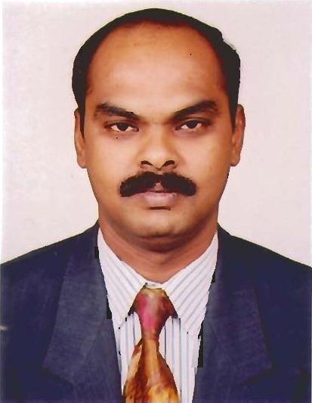
CURRICULUM VITAE

SATHURAPPAN

SATHURAPPAN.365981@2freemail.com

career objective

Senior position in service industry enabling to utilize my knowledge in Finance, Accounts, Operations and Marketing. Long-term goal is to specialize in Accounts & Operational Excellence.

_______________________________________________________________________

SUMMARY OF EXPERIENCE:

Over 19 years work experience in the niche area of services in Finance & Accounts, Procurement & Operations for Oil & Ship Maintenance sector and specialization includes the following.

Finance & Accounts

- Processing overall accounting functions of the company.
- Independent finalization of books of Accounts.
- Preparation of Monthly Profit & Loss account
- Preparation of Monthly MIS Report to monitor the performance of the company.
- Preparing Monthly Production Report and analyzing the same.
- Preparing Job Costing and analyzing the recovery.
- Conducting Monthly inventory on Oil Stock and plant machinery.
- Analysis & control of the direct and indirect expenses.
- Review and approval of employee payroll system.
- Handling insurance policy and claims.
- Invoicing of jobs carried out and projects completed in conjunction to the contract.
- Daily basis report generation on the debtors & creditors.
- Negotiation and Discounting with suppliers & sub-contractors.
- Liaison with the bankers for arranging funds and Bill discounting etc.

Procurement & Expediting
- Review draft tender documents to ensure all systems and components of the tender are included
- Assist preparation of tender documentation queries to consultants/clients to confirm and collect any missing data including; shipping costs, insurance, and any regional requirements
- Assist preparation of technical proposal documents like manpower histogram, equipment schedule, construction schedule, work procedures and other related reports to ensure the Company is positioned to win and secure bids
- Develop tender cost summaries including equipment, materials and labor calculations for final approval
- Review and generate Bill of Quantity against system drawings to ensure alignment and to identify materials types & quantities and prepare equipment lists and rough drawings for cost estimation
- Prepare specification documents to submit to vendors for quotations of cost/price of materials and equipment and evaluate same against tender specifications to include in final tender documentation
- Build relationships and liaise with internal customers and external suppliers and vendors and manage daily correspondence for quantities, costs and specifications.

OPERATIONS
- Co-ordinations and arrangements of all aspects of all business related operations.
- Liasioning with clients including vessel master, chief engineer, terminal in-charge etc. to ensure smooth and safe operations.
- Detailed report preparation after completion of every operation and submit to related authorities.
- Attend and resolve issues in case of any abnormality during execution of operations.

WORK EXPERIENCE

M/s BRAVOS Ships Tank Cleaning LLC, Dubai-UAE | Managing Partner | January 2012 to till date
M/s. Jumeira Sky Ship Maintenance Co. LLC. Dubai-UAE | Manager – Finance & Accounts | April 2010 to November 2011
M/s. Emirates Environmental Protection Co. LLC. Duba-UAEi | Chief Accountant | November 2001 to March 2010
M/s. Al Ensel Building Contracting Co. Dubai - UAE | Chief Accountant & Administrator | January 2000 to October 2001
M/s. Almulla Construction Co. LLC, Dubai – UAE | Accounts Assistant | December 1996 to December 1999
M/s. New Line Finance Limited. Chennai, India. | Accountant | February 1996 to November 1996
M/s. Associated Investment Consultant & Finance Services (P) Ltd. Chennai, India. | Accountant | August 1994 to January 1996

SUMMARY OF QUALIFICATION

Institute of Chartered Accountants of India, (Articleship completed)

Articleship (1991-1994) : Statutory Audit: - Handled statutory audit of various private limited and public limited companies including independent finalization of accounts.
M/s. Srinivasan & Co.
Chartered Accountants

Internal Audit: - Performed internal audits of private and public limited companies including devising internal control system in selected areas of companies.

Taxation: - Handled tax audits including finalization of Tax Statements for various proprietary concerns, firms and companies.

EDUCATION
Bachelor of Commerce (B.Com)
From 1988 to 1991
Madurai Kamaraj University, Tamil Nadu, India

Office Secretary Ship, Short hand & English Typewriter in higher grade (+2)
From 1985 to 1988
State Board, Tamil Nadu, India.

COMPUTER PROFECIENCY

Diploma in Computer Application (DCA)
Bureau of Data Processing System Ltd.
Tamil Nadu, India.
_______________________________________________________________________

LANGUAGES KNOWN : English, Hindi, Tamil, Telugu & Malayalam

DRIVING LICENSE : Holding a valid UAE driving license

_______________________________________________________________________

