MANUR
MANUR.365998@2freemail.com

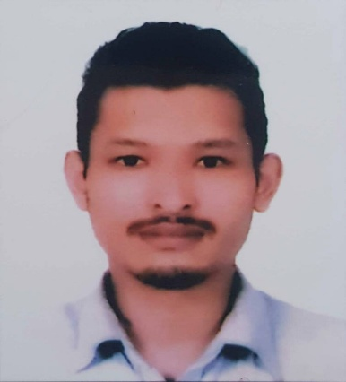
PROFESSIONAL SUMMARY ________________________________________
Motivated Demi chef de partie offering over 4 years of experience in the food industry. Focused on high standards for taste and quality, while maintaining profitable margins. Superior communication and leadership skills.

SKILLS _______________________________________________
- Strong attention to safe food.  - Preparation and cooking of food handling procedures  - Steaming, Grilling ,Poaching, Braising, Barbecue cooking technique | - Hospitality and service industry background  - Institutional and batch cooking  - Excellent ability to communicate effectively  - Fast learner

WORK HISTORY ___________________________________________
01/2015 to 03/2017 Demi chef de partie
Ratomato organics and bbq bistro - Lazimpat, Nepal
- Prepared food items consistently and in compliance with recipes, portioning, cooking and waste control guidelines.
- Managed kitchen staff by orienting, training, assigning, scheduling, supervising, evaluating and enforcing discipline when necessary.
- Verified proper portion sizes and consistently attained high food quality standards.
- Instructed new staff in proper food preparation, food storage, use of kitchen equipment and utensils, sanitation and safety issues.
- Ensured all staff understood expectations and parameters of kitchen goals and daily kitchen work.
12/2012 to 11/2014 Commis chef
Royal Singi Hotel - Kathmandu, Nepal

- Promptly reported any maintenance and repair issues to Sous Chef.
- Accurately and efficiently prepared healthy, delicious fish, meat and vegetable-based dishes
- Verified freshness of products upon delivery.
- Practiced safe food handling procedures at all times.
EDUCATION ___________________________.________________________
2012 Higher Diploma in Hotel Management: Hotel Management
International school of Tourism and Hotel Management
Kathmandu, Nepal
- Coursework in Hospitality Management
- Basic Vocational Certificate First Cook
- Went for internship in Gorkarna Forest Resort,Nepal And Maxims Genting highland,Malaysia for the duration of ten months
2009 High school Diploma: Commerce
Times international higher secondary school
Kathmandu, Nepal
CERTIFICATIONS _________________________________________________
- International school basketball tournament (Participation)
  - Certification of merit, Nepal (1st and 3rd position)
  - Edu-com, Nepal
  - Central wushu guan, Nepal
  - Standard Tourism and Hotel Training center Pvt.Ltd (Continental cuisine)
  - Shangrila Training Center (sushi)

