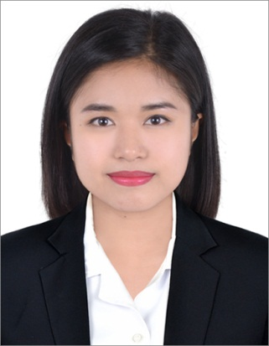
Rochelle
Rochelle.366007@2freemail.com

Objective: To be a part of a company that gives me platform to develop new skill set while utilizing my present knowledge.

Working Experience:

Management Trainee
RE&S Enterprises Pte. Ltd. Singapore
March 28, 2013 – August 23, 2016

- Draw up client bookings for tables and ensure that tables are set before clients’ arrival
- Responsible for the welcoming and the well-being of the guests
throughout their stay
- Manage the front desk by receiving incoming calls, greeting and attending to customers
- Keep records of guests who visit the restaurant
- Assist customers with answers to queries, and proffer solutions to issues within your capacity
- Collaborate with other restaurant staff and the management to ensure that customer complaints are properly attended to in a timely manner
- To comply with all security and maintenance measures to ensure the protection of
guests and company property.

Attributes and Qualities:

- Excellent phone etiquette
- Excellent communication skills
- Multitasking ability
- Ability to pay attention to details
- Ability to maintain orderliness.

Educational Background:

2011 – 2012 BMC INTERNATIONAL COLLEGE, SINGAPORE
Certificate in Hotel Management

I hereby certify that the above information is true and correct according to the best of my knowledge and ability.

