Muhammad
Muhammad.366017@2freemail.com 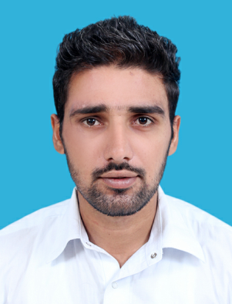
CAREER OBJECTIVE
To work in a dynamic organization where advancements are based on achievements, aspiring to utilize my skills to the maximum, while contributing to achieving a new high in company’s excellence.

QUALIFICATION | YEAR | DIVISION/GRADE | BOARD/UNIVERSITY
BBA(HONS) | 2016 | 3.55 CGPA  Specialization in finance | Punjab University (Jhelum Campus)
I.COM | 2011 | 853/1100 (1st) | BISE(Rawalpindi)
Matric | 2009 | 853/1050 (1st) | BISE(Rawalpindi)

COMPUTER KNOWLEDGE
- MS Windows XP, Windows 7, Windows8.
- MS Office. Ms Excel, Ms Word
- Internet Applications

OTHER SKILLS

- Well Communication Skill.
- Ability To Convince To Others.
- Self Confidence In My Personality.
- Having Flexibility In Myself To Change According To The Circumstances Of
Organization.
- A sportsman with a good sportsman spirit.

EXPERIENCE
Internship In Allied Bank | 6 Weeks
Call center experience | 3 months
Accountant experience in Global customer  Services | 4 months
Now working as an accountant in  Sama Al Jazat Building Contactors (U.A.E) | In progress

LANGUAGES

- English
- Urdu
- Punjabi

REFERENCE
- Will be provided on demand.

